Wicca element crystals
[Air] Communication,Travel,Intellect|Mottled jasperUncommon mottled jasper unique home decor sphere 13.25 cm diameter 8.6 lb weight brought to you byhttp://www.sorianocollection.com/mineral-specimens/index.php/archive/mottled-jasper-sphere-2/ #ns 21 - $200 “below”
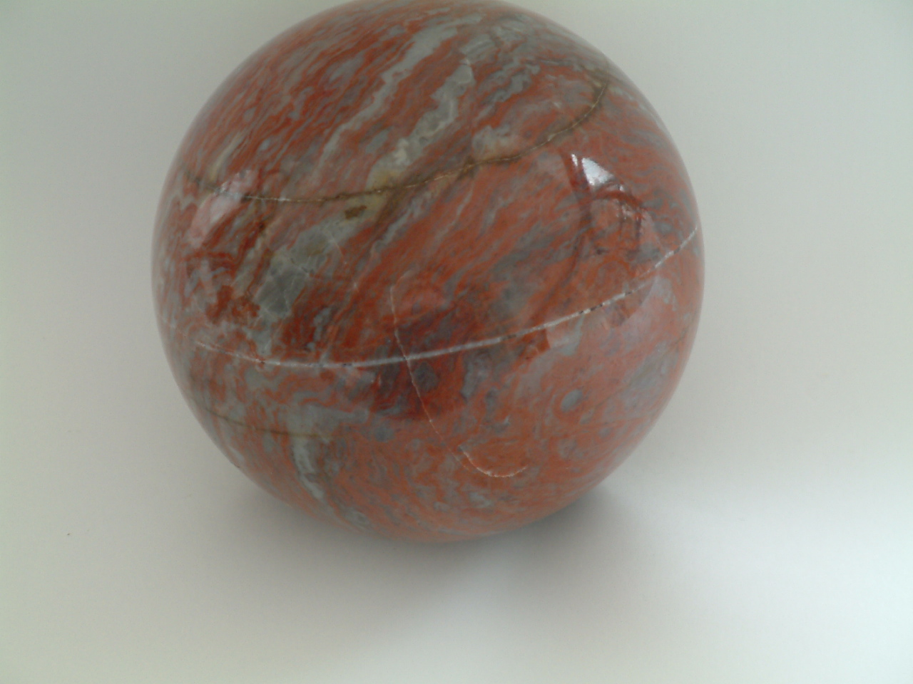
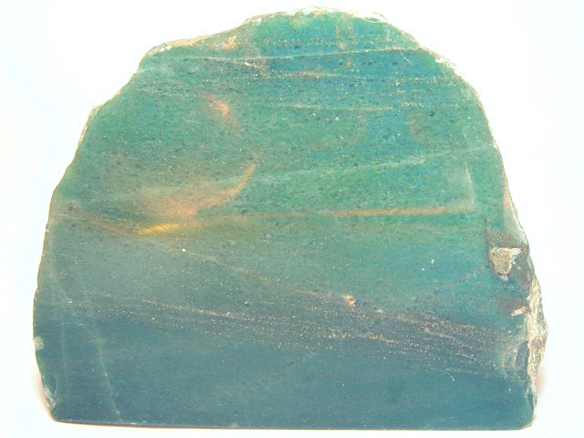
Aventurine
From Karnataka, India “above”
Mica “below”
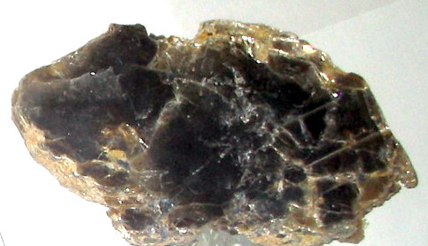
Pumice “below”
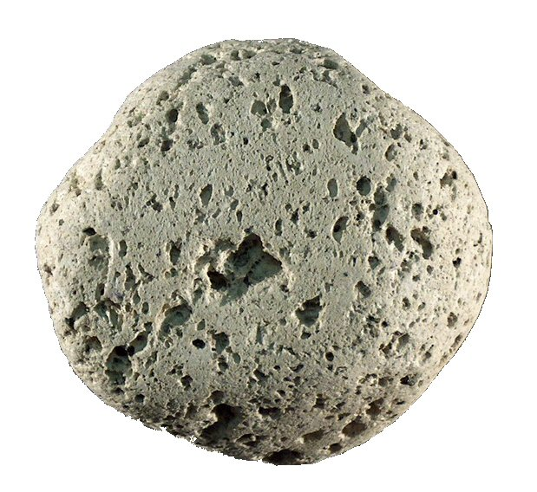
Earth Peace, Grounding, Centering, Fertility, Money, Business Success,
Stability, Gardening
Green agate “below”
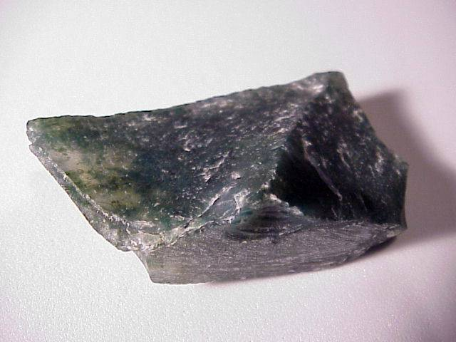

Green calcite “below”
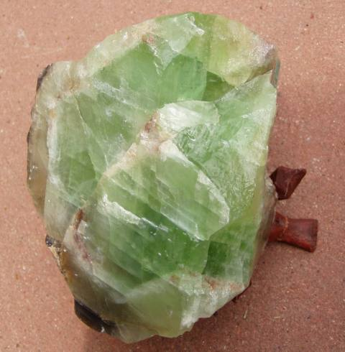
Wiccan stores
www.newageincense.com/shop/index.php?cPath=64
wiccanexchange.com
www.bellirosa.com
www.forestwitch.com
store.higherheart.com

