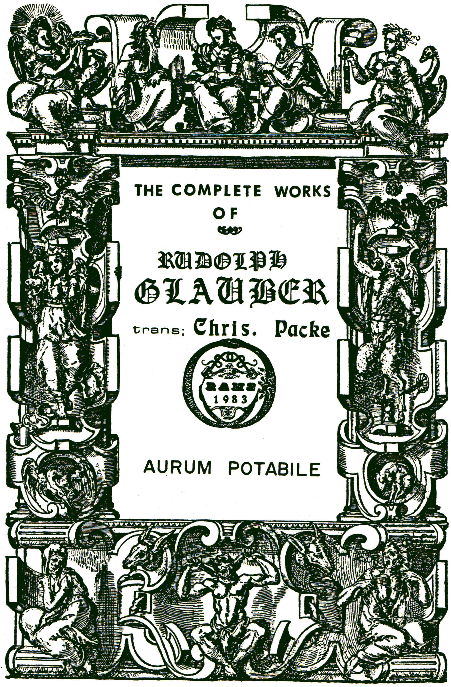

A
TREATISE
Of an Universal Medicine;
or,
A TRUE AURUM POTABILE.

Being an accurate Description of a True Universal Medicine, and of its admirable Virtue and efficacy which it sheweth upon the VEGETABLES, ANIMALS, and MINERALS. A Gift presented unto all such Noblemen as are desirous to preserve their Health, and to attain to a Long Life; it being an UNIVERSAL MEDICINE, or A TRUE AURUM POTABILE.

After that I had by GOD’S assistance described three excellent Processes in the Continuation of the MIRACULUM MtTNDI, and had bestowed the same on men of several orders, that thereby they might the easier, and with a safer Conscience, provide themselves with Food and Raiment: I was also desirous of tendering some small Present to Noblemen too, and such who are of eminent power and authority, and whom I had not forgotten to present with some Gift, which may serve for the preservation of their good health for a long time, and for the restoration of it when lost.

For it is a thing of the greatest Concernment for the Nobles, and such men as are placed in the degree of Power and Authority, to have the fruitation of bodily health, whereby they may wisely rule over the subjects committed unto them by God, and may use a sound mind about the defence of the Good, and the punishment of the Ungodly. Now a Sound mind inhabiting in a sound body, doth proceed (next after the Divine Grace) out of a sound Heart and Brain. And it cannot be, that a publick Government can be rightly and well administered without a good Health; and this is as clear and evident as the noon—day light is. Forasmuch therefore as the safety and preservation of all Kingdoms and Republicks is placed in the Wisdom of their Rulers and Magistrates, and that imprudence and ignorance of the Rulers is wont to ruin their Subjects, it is a thing of the higest consequence to save the Head of the whole Kingdom or Country sound, whole, cheerful, prudent and ingenious, and that he be not made unfit or uncapable for the Government, by diseases, sadness, slothfulness, and stupidity. Therefore the love of my Neighbour constrains me to publish this Universal Medicine for
the sake of the Great ones of the World, seeing it is so much conducive to the perpetual felicity and happiness of a sound and good Government; for no man can be said to be a sound man, if he be not of a sound constitution of Body. What benefit, I pray, can a sick man bring to himself, or to other men? Verily none at all, but is rather an hindrance and detriment both to himself, and unto others likewise: For when the Head is ill, there are a great many Members must serve it; but if the Head be sound and well, it exerciseth the government of the whole Body very happily.
What profit has a man that is tormented with Sicknesses and Dolours, of all his vast Wealth and Riches, since he can neither use them nor enjoy them, looking upon them with a kind of nauseate, and at Last leaving them with grief behind. Certainly a sound body is to be preferred far before all the Treasures of this World, and no body will gain-say this. He is to be judged the Happiest man, that possesseth those two the greatest Gifts of God, viz, good Health and Riches. Sickness and Poverty are to be esteemed worse than even Death it self.
We sometimes see, that pious Magistrates and Governours are snatcht away, and killed with small Diseases, which otherwise might have yet Ruled very many years over their subjects, had they had but good Medicamerits, by help whereof they might have been succoured.
As for the way of Conserving good Health, and recovering it when lost, this little Book doth most exactly shew the same, which I commend unto all those who are desirous of its preservation.

