Woodward Effect Experimental Verifications

Paul March

Lockheed Martin Space Operations (LMSO), Houston, TX 77058, USA
Phone: 281-333-6854, e-mail: paul.march@lmco.com

Abstract. The work of J. F. Woodward (Woodward, 1990; 1996a; 1996b; 1998; 2002a; 2002b; 2004) on the existence of “mass fluctuations” and their use in exotic propulsion schemes was examined for possible application in improving space flight propulsion and power generation. Woodward examined Einstein's General Relativity Theory (GRT) and assumed that if the strong Machian interpretation of GRT as well as gravitational / inertia like Wheeler-Feynman radiation reaction forces hold, then when an elementary particle is accelerated through a potential gradient, its rest mass should fluctuate around its mean value during its acceleration. Woodward also used GRT to clarify the precise experimental conditions necessary for observing and exploiting these mass fluctuations or "Woodward effect” (W-E). Later, in collaboration with his ex-graduate student T. Mahood, they also pushed the experimental verification boundaries of these proposals. If these purported mass fluctuations occur as Woodward claims, and his assumption that gravity and inertia are both byproducts of the same GRT based phenomenon per Mach’s Principle is correct, then many innovative applications such as propellantless propulsion and gravitational exotic matter generators may be feasible. This paper examines the reality of mass fluctuations and the feasibility of using the W-E to design propellantless propulsion devices in the near to mid-term future. The latest experimental results, utilizing MHD-like force rectification systems, will also be presented.

THE NEED FOR THE TECHNOLOGY

An interstellar robotic propulsion problem derived several years ago (Mallove and Matloff, 1989), demonstrated the need for better power and propulsion technology for any future explorations of the outer solar system and beyond. This example provides the specific impulse (Isp) requirements needed to send a probe to our solar system’s nearest neighbor, the Alpha Centauri solar triplet system, which is 4.3 light years or 40.61 trillion (10¹²) kilometers away from Earth. The proposed interstellar mission consisted of determining the propellant mass fraction (PMF) of a conventional rocket powered probe for a one-way Proxima Centauri fly-through mission with the following conditions and comparisons:

- Required Cruise Velocity: 0.01 c (3,000,000 meters/sec)
- Flight Time assuming constant velocity from Sun to Alpha Centauri: 430 years
- Estimated mass in the Universe: 1x10⁸⁰ atoms
- Estimated propellant load for Shuttle External Tank (ET): 720,000 kg or ~4 x 10³² atoms
- For a local reference, the Space Shuttle Orbiter has a mass of ~100,000 kg
- Shuttle Cruise Velocity = 9,100 meters/sec or 330 times less than the proposed stellar fly-by.

These are very modest requirements for an interstellar mission. Now plotting the PMF verses specific impulse using the rocket equation to solve for the propellant mass fraction as a guide, see Equation 1, the results of this relationship for the proposed Alpha Centauri fly-by mission is shown in Figure 1 for various values of specific impulse.
Mass _{start} / Mass _{final} = e Change in Velocity / Exhaust Velocity (1)

Assuming some “reasonable” figure for the desired PMF, as exemplified by an economical jet airliner such as the long-range version of the Boeing-777, which has a fuel to mass ratio of about one to one, i.e., a vehicle with the gross liftoff mass that is one-half fuel and the other half dry structural mass plus payload, yields a target PMF of 2.0. This implies that what’s needed is a conventional rocket engine with an Isp of around 440,000 seconds to get these desired results. Even backing off to a PMF of 21, which has never been achieved in practice, still requires an Isp of at least 100,000 seconds. Unless a scoop-ramjet rocket can be developed using interstellar gas as propellant, this range of Isp or even higher is what has to be faced in developing a conventional rocket for interstellar flights.

From Equation 1 one can also see that to obtain a PMF of 2.0, the Delta-V/exhaust velocity ratio has to be around 0.70, which implies that for a terminal velocity of 3,000 kilometers/sec, a high power rocket needs an exhaust velocity of about 4,300 kilometers/sec. For comparisons, the Space Shuttle’s Main Engine (SSME) LOX/Hydrogen chemical rocket engines have an exhaust velocity of about 4.5 kilometers/sec and power levels of ~10x10⁹ Watts, which is the power/thrust level that could be typical for this type of interstellar mission. Now the SSME’s exhaust velocity is 955 times slower than the required exhaust velocity for this proposed slow interstellar probe. When you consider that the required rocket exhaust energy scales with the square of the velocity per the Newtonian kinetic energy equation, and that our interstellar rocket requires (955)² = ~912,000 times as much energy per pound of propellant than what the SSME provides its propellant, or ~9.0x10¹⁵ Watts, one can start to see the magnitude of this problem. Since nuclear fission, fusion and anti-matter reactions provide 1-to-100 million times as much energy per unit mass as chemical reactions, this can be accomplished with optimized nuclear powered rockets, but it’s hardly desirable due to the proposed very slow by human standards transit times of 430 years.

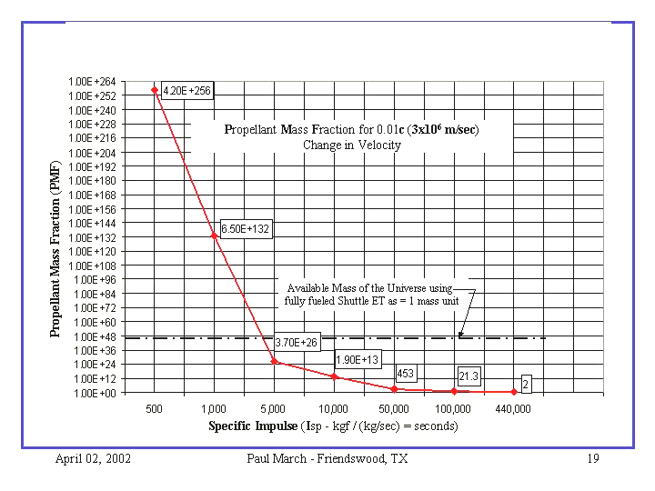

FIGURE 1. Vehicle Propellant Mass Fraction (PMF) in 10^{X} verses Isp for a Slow Interstellar Mission to Alpha Centauri.

So what’s the best rocket performance that can currently be had at the moment? The highest performance rocket that has been fielded to date, the NASA/Glenn Research Center’s DS-1 ion rocket, has a maximum thrust of 92-millinewton and an Isp of around 3,000 seconds dependent on input power (NASA GRC 2002). That is two orders of magnitude shy of the required interstellar probe Isp performance and that is for a rocket powered vehicle that will take 430 years to get to our nearest interstellar neighbor! Even the best yet to be built or designed atomic powered rockets can only manage an Isp between 800 seconds and ~1,000,000 seconds, which would do wonders for a solar system based space transportation system, but would be a dismal failure for human interstellar flights. No, if fast human space flights to the outer solar system or to the near by stars that take months to years or less transit times and not centuries in duration is ever to become a reality, something much better has to be found in the propulsion arena, for conventional rockets just won’t cut it. Thus the need for a breakthrough in propulsion physics is demonstrated.
Breakthrough Propulsion Physics (BPP)

Marc Millis (1997) who ran the NASA’s Glenn Research Center (GRC) sponsored Breakthrough Propulsion Physics (BPP) program and later, Woodward (Woodward, 2002a), defined what propulsion technologies need to be developed before practicable starships can become a reality. They are:

- Traversable Wormhole and Navigable Warp Bubble (TW & NWB) field generators.
- Prompt, near lightspeed travel. (Like TW & NWB generators, this technology requires the generation of “Exotic” Gravitational / Inertial (G/I) matter that reduces the effective mass of vehicles.
- “Propellantless Propulsion (P-P) schemes that involve the production of accelerating forces without the expulsion of propellant mass from the vehicle. P-P implies a rocket engine performance with an infinite Isp.

Looking at these three requirements and noting the current sad state of the art in space propulsion, one could surmise that the third item on the list, Propellantless Propulsion or P-P, might require the least amount of basic research to discover and be the easiest technology to implement in the next twenty years. So how does one make a P-P device that can accelerate a local mass without throwing mass overboard and thus apparently bypassing Newton’s third law of motion, or in other words, how can the rocket propellant be recycled? In order to better understand the challenges of manifesting this system in practice, a list of concerns is presented herein:
- How does the P-P scheme account for coupling to the distant matter in the universe relative to which all accelerations take place per Mach’s Principle?
- How is momentum (and energy) conserved globally?
- How are the minuscule alleged effects (normally never seen) promoted into effects large enough to have practical value?

The answer to the first and second questions, at a minimum, require a modification to GRT that fully integrates the strong form of Mach’s Principle and also allows for momentum and energy (momenergy) exchanges between an accelerated local mass and all the rest of mass of the universe. An answer to the third question assumes that the first and second questions have been addressed sufficiently to provide some direction and hope of obtaining possible solutions to these problems. Woodward has provided a possible path.

THE WOODWARD EFFECT

J. F. Woodward, joined later by his ex-graduate student T. Mahood, has already provided a theoretical explanation in several papers over the last fourteen years (Woodward, 1990; 1996a; 1996b; 1998; 2002a; 2002b; 2004 and Mahood 1998; 2000; 2001) for the Woodward Effect (W-E). Other researchers (Funkhouser 2003) have also come to the tentative conclusion that the relationship between inertial mass and Mach’s Principle could be used to integrate macroscopic gravitational / Inertial (G/I) phenomenon such as the speed of light with the quantum mechanical realm including the derivation of the Plank Length, thus reinforcing the credibility of Woodward’s propositions. Woodward’s W-E papers, the first of which was published in 1990, explain in detail Woodward’s ideas on the origin of inertia, mass fluctuation and P-P proposals including a STAIF-2004 presentation as well, so just a summary of Woodward’s theoretical rational will be provided now for reference.

The W-E is based on the idea that when a mass is accelerated through a local potential field gradient, its local rest mass is transiently perturbed about its at-rest value. The resulting acceleration induced “mass fluctuations” can then be used to generate an unbalanced force in a local mass system, which can be used for local propulsion or energy generation. Local system energy and momentum conservation is maintained by interactions with all the distant mass in the universe via G/I like Wheeler/Feynman radiation reaction forces. Therefore to accelerate a spacecraft here, the Machian interpretation of inertial reaction forces means that each star or other distant matter in the universe will move in the opposite direction of the locally accelerated mass in response – even if only on a nano-nano meter scale. Conservation of energy and momentum must be maintained, but nature doesn’t say how big the system box has to be nor when the accounting has to be done.

A derivation from first principles of the W-E’s controlling equation was performed by Mahood (1998) with significant points summarized as follows:

- The W-E is described by a d’Alembertian partial differential wave equation as noted in Equation 2 with the gradient of the gravitational potential φ being equated to Newton’s gravitational source term and three transient mass terms, composed of the gravitational scalar potential φ, the proper instantaneous matter density of the accelerated local mass ρ₀, and the speed of light c:

$Ñ^{2}f−\frac{1}{c^{2}}\frac{¶^{2}f}{¶t^{2}}=4{pGρ}_{0}+\frac{f}{ρ_{0}c^{2}}\frac{¶^{2}ρ_{0}}{¶t^{2}}−\frac{1}{c^{4}}{\left(\frac{\text{¶f}}{¶t}\right)}^{2}−{\left(\frac{f}{ρ_{0}c^{2}}\right)}^{2}{\left(\frac{{\text{¶ρ}}_{0}}{¶t}\right)}^{2}$
1 2 3 4
(2)

- The first right hand side (RHS) term-1is the Newtonian gravitational source term and proper mass density.

- The second RHS term-2 is a transient “Impulse” G/I matter term which time averages to zero, but may perhaps, with the application of externally applied and appropriately timed force rectifications, be used to build a P-P device. The phrase “force rectification” as used here implies that if one accelerates the local mass during a low-mass state and then decelerates it during a high-mass state, a net force can be extracted from these transient mass fluctuations. If the W-E impulse term’s alternating +/-mass magnitudes become large enough, these large mass fluctuations will then determine the magnitude of the W-E equations forth term. This is accomplished by transiently driving the ρ₀ matter density term very close to zero, i.e. six places or better, thus making the W-E equation a VERY nonlinear G/I relationship loaded with unexplored qualities and possibilities.

- The third RHS term-3 is the time rate of change of the gravitational potential but due to the very small 1/c⁴ factor in this term and the fact that φ is considered a near constant; this term can typically be ignored.

- The fourth RHS term-4 is the “Exotic” G/I matter generator term of the W-E equation and it is always negative going. If the impulse term is driven hard enough so that the accelerated mass’s dynamic density ρ₀ goes very close to zero, then the W-E equation’s fourth term’s transient exotic mass density could become very large.

Simplifying Equation 2, results in Equation 3, an Excel plot of which with arbitrarily chosen control parameters is shown in Figure 2. This plot shows the relative or normalized relationships between the W-E impulse and exotic matter terms when driven with a moderate amplitude sinusoidal excitation. Note that the magnitude of the exotic G/I matter has two peaks per cycle at the highest rate of change of the impulse term’s proper matter density.$4{πGρ}_{0}+\frac{1}{ρ_{0}}\left(\frac{∂^{2}ρ_{0}}{∂t^{2}}\right)−{\left(\frac{1}{ρ_{0}}\right)}^{2}{\left(\frac{∂ρ_{0}}{∂t}\right)}^{2}$
(3)
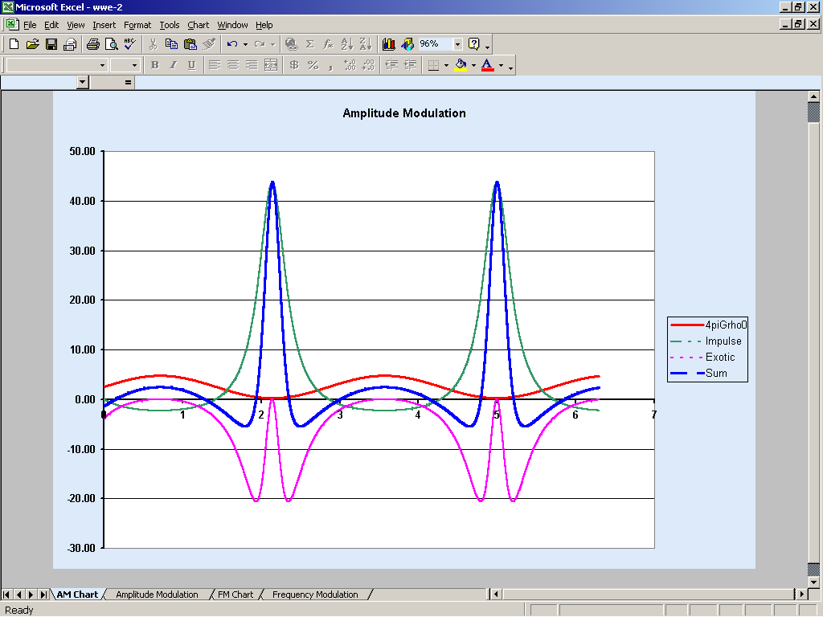
Two Peak Exotic Matter Pulses/Cycle
Peak Impulse Term
Matter Density
Impulse + Exotic
4πGρ₀
ω1 Base: 2.20Hz
G: 0.20
ρ₀ Base: 1.00
ρ₀ %: 0.90
Seconds
Rho (ρ₀)
Peak dρ₀/dt
360º
0º

FIGURE 2. Excel W-E Equation 3 Solution Using Sin-X Driving Function with Y-Axis = Delta Mass.

Woodward has also developed and executed a large number of “tabletop” experiments that seem to confirm to some degree the existence of these mass fluctuations and their potential for use in a Uni-directional Force Generator (UFG). John Cramer of the University of Washington, Seattle, WA has explored related super-luminal energy transfers (Cramer, 1997) and also performed a series of vibrating wire experiments (Cassissi et al., 2001) on the existence of mass fluctuation under contract with Marc Millis’ NASA/Glenn BPP program with published results to date being inconclusive. H. Brito of the Instituto Universitario Aeronautico, Cordoba, Argentina has published two known papers suggesting a possible P-P effect based on accelerated local mass. His latest paper described, using piezoelectric materials, the expression of small micro-newton force productions (Brito, 2003).
How can the W-E be used to generate a P-P device?

There are two elements in the W-E equation that might be used for building a Unidirectional Force Generator or UFG. The first is using the W-E’s impulse term to generate a P-P device utilizing external force rectification inputs. The second is using the W-E’s exotic matter term’s negative-going mass reductions for either increasing the impulse term’s total mass fluctuations or to make a G/I mass reduction system for a rotary force rectified and amplified P-P device using centripetal accelerations. Both approaches have been or are currently being investigated.

USING THE W-E IMPULSE & EXOTIC MATTER TERMS TO BUILD A UFG

Assuming that mass fluctuations really do exist, in theory, a UFG can be built using externally applied forces that can push on the “active” mass when it is lighter and then pull on the active mass when it is heaver in a cyclic manner, thus generating a net time-averaged force per Newton’s F=ma equation. This results in Equation 4 on a per cycle basis:
F_{net} = Σ(m₁a – m₂a) (4)

If one uses a sinusoidal drive signal to excite the W-E’s impulse term, the net force equation then becomes per Equation 5 for a W-E “Shuttler” UFG:
F_{net} = − 2ω²δl_{o} δm cos θ (5)

Where ω is the angular frequency, δl_{o} is the magnitude of the “Push / Pull” displacement produced by the externally applied force, δm is the magnitude of the instantaneous mass fluctuation and θ is the phase angle or timing delta between the externally applied displacement and the internally generated mass differentials. Note that the net force should scale up with the square of the drive frequency, the magnitude of the delta-mass and applied rectifying forces.

Woodward’s first attempts at building a W-E based UFGs used piezoelectric (PZT) stacks that apparently produced very small W-E impulse term forces that were on the order of micro-to-milli-newton (Woodward, 1996a). Woodward’s 2001 brass reaction mass PZT stack assembly that weighed ~130 grams on the other hand, used the W-E’s exotic term to produce apparent weight reductions on the order of ~0.10-to-2.2 grams as measured by a U-80 magneto-resistive weight sensor. Woodward’s averaged test results for this time period utilizing the assumed W-E’s exotic mass reductions produced during PZT stack mechanical resonance is provided in Figure 3. One should note that to elicit the W-E’s exotic matter generation, which requires large mass fluctuations that the PZT stack should be operated at one of its mechanical resonances to minimize the required input power. This resonant condition, which multiplies the effective input power by the PZT stack’s mechanical Q, can reduce the input power needed to express these exotic mass productions by factors of ~25-to-1000 depended on the selected piezoelectric materials.

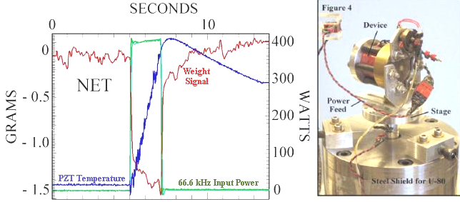

FIGURE 3. Woodward’s Typical U-80 Load Cell Data showing a Possible 1.5 Gram Weight Loss.

It should also be noted at this point that Woodward and his colleagues (Mahood et al., 2001; Woodward, 2002b) went to great lengths to verify that any dynamic ultrasonic loading of the spring diaphragm used in Woodward’s U-80 weight measurement instrument was not the cause of the recorded weight reductions. This included using various vibration isolation techniques, different types of support springs, orientating the test article alone and the test article/U-80 combination in the 0, 90, and 180-degree orientation relative to the local g-field during data runs, carefully noting various thermal effects, calculating expected electrostatic effects and accounting for electromagnetic interference (EMI) in the instrumentation. These validations ruled out obvious experimental error.

Another issue though with Woodward’s PZT test articles was that they were very difficult to keep operating and garnering successful data runs. After searching for a number of explanations for why these PZT based stacks were so difficult to use, Woodward and his colleagues found that the most probable cause for their erratic behavior was due to the use of piezoelectric crystals with “ageing” memory characteristics and relying on ultrasonic pressure waves to force rectify the W-E mass fluctuations and/or reductions into a uni-direction force or weight reduction. The transient mass fluctuations propagate through the PZT stack crystals at some substantial percentage of the speed of light in lockstep with the applied E-field, while the ultrasonic force rectification waves are traveling through the PZT crystals at the speed of sound through that same material, which are some 5 orders of magnitude slower than the applied E-field. These very large velocity differentials between the E-field driven transient mass fluctuations and the much slower ultrasonic standing waves propagating back and forth in the PZT crystal stack structure, generated large variations in the phase relationship between these two signals.

For a stable unidirectional force to be created in a UFG, these two force signals must have the correct and stable phase relationship between them for the W-E force to be expressed at all. This being the case, a lesson was taken from Hector Brito’s propulsion work (Brito, 2003) and it was decided to force rectify the W-E’s impulse term’s mass fluctuations with the application of a Magneto-Hydro-Dynamic (MHD) like force rectification system using an alternating current (ac) magnetic B-field, applied to the PZT stack at 90 degrees to the applied E-field. Since the magnetic B-field travels at the same speed through the PZT crystal as the E-field, variations in the phasing relationship between these two E and B-field drive signals should be minimized and made controllable as compared to the hybrid E-field/ultrasonic pressure wave approach.

During the period from 2000 and 2001, a replication of this W-E data using one of Woodward’s PZT test articles was attempted in this lab using a homegrown test rig and vacuum system. These efforts were complicated by the seismic noise platform of the lab’s location, (0.5-to-1.5 gram-force peak in the 0.5 to 5 Hz range), which was at least an order of magnitude higher than Woodward’s lab’s 50-to-100 milligram-force noise levels. Some interesting data during several frequency sweeps of Woodward’s PZT test article were noted, but nothing conclusive was obtained. Considering the location of the lab in a second floor wood framed house, this outcome was no great surprise. So a new attempt at verifying the W-E was initiated by finding ways to lower the lab’s seismic noise platform and/or increasing the W-E signal output with preference given to increasing the output signal.

Taking the W-E νxB Road

The controlling equation for the νxB form of W-E force rectification is the Lorentz Force Law, which is the basis for the “Right Hand Rule.” It is displayed in Equation 6, where F is the resulting force vector, q is the electric charge, (the total number of PZT accelerated Ti & Zr caged ions), E is the applied alternating electric field, v is the charge’s instantaneous velocity, and B is the alternating magnetic flux density. From Equation 6, it can be seen that to maximize the force output F, the magnitude of the q, E-field and B-field have to be maximized. This implies that a large amount of energy storing media, excited by high peak voltages with high dV/dt and large magnetic fluxes are a must for the W-E to express large vxB force rectified output forces.

F = q (E + (v x B) (6)

During the first half of 2003, Woodward built several of these νxB test articles (Woodward, 2004), indicating that this approach had merit and should to be pursued. Also noted during this time was that the magnitude of the impulse term’s mass fluctuations should scale with the product of the input power and operating frequency, and that the net unbalanced force being generated by the νxB force rectification stack should increase linearly with operating frequency, EXCEPT when the impulse term starts generating a large percentage of exotic G/I matter relative to the UFG’s active mass via the W-E equation’s fourth term. When this starts to occur, the νxB force output could scale up to the square of the operating frequency, or even higher. These observations suggested that working at much higher frequencies than Woodward’s current 25kHz-to-100KHz operating range, which provided first generation νxB force outputs of approximately 1/4 milli-newton, could provide much greater νxB force outputs by a factor of hundreds or even more, dependent on the selected increase in operating frequency and input power.

Noting this possibility of much higher W-E force outputs that could be detected in this lab’s high seismic noise environment, two νxB test articles are currently being assembled, one optimized for 50kHz, the other for 2.0MHz to 10 MHz and will be investigated in the test rig shown in Figure 4. The test article’s capacitors will be Vishay/Cera-Mite high voltage disk types optimized for energy storage and not physical movement. The B-field generator will be a hand-wound solenoid over the capacitors, interspaced with medium mu (μ=20 & 60) magnetic core materials. Any resulting W-E νxB generated force will be detected as a weight reduction in a Mu-Metal shielded cantilever beam load cell, while being driven at various frequencies starting at 50 kHz using audio amplifiers and then going up to 10 MHz.

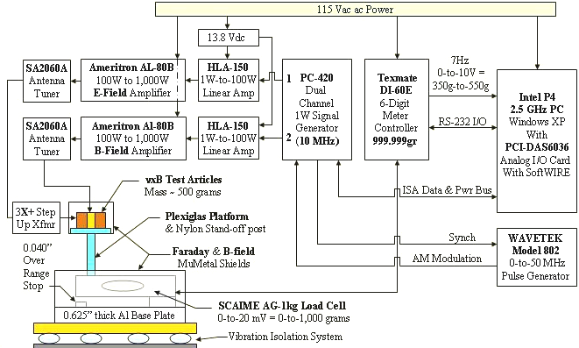

FIGURE 4. Block Diagram of W-E High Frequency (HF) νxB Test Rig.

So, other than using the W-E’s impulse/exotic G/I matter terms to generate a semi-continuous unbalanced force by using magnetic fields to force-rectify the resulting mass fluctuations, is there any other P-P devices that could benefit from the W-E in the next twenty years? An idea offered by John Cramer (Cramer, 2002), proposed the use of rotating variable masses on the rim of a flywheel, using the flywheel’s rotationally induced centripetal forces to force-rectify and magnify small negative-going mass fluctuations if they could be obtained. If a controllable G/I exotic matter generator can be fabricated, as Woodward’s work implies it might if the noted PZT material problems can be resolved, one only needs to generate a transient net mass reduction in the flywheel’s rim on the order of a few grams, to be able to build a rotary UFG with hundreds to thousands of newton of resulting force in any desired direction. A rotary test article weighing approximately 4.6kg is also being developed in this lab that could produce over 100-newton with an average 1-gram mass reduction in the flywheel rim while rotating at 15,000 RPM. That is IF a consistent and reliable transient mass reduction generator can be built.

CONCLUSION

Over the last thirteen years, several researchers have discovered that mass fluctuations may exist under certain circumstances and that they could be used to create propellantless-propulsion or even more exotic propulsion systems that might open up the universe to human exploration. These purported W-E mass fluctuations could be used to recycle rocket propellant, make a local mass transiently reduce its apparent magnitude, or in the long-term, generate large exotic G/I matter concentrations that could be used in TW & NWB field generators. Since the magnitude of the W-E impulse term’s mass fluctuations scale with the product of input power and frequency, and the resulting mass fluctuation’s νxB force rectifications scale with the magnitude of the total mass fluctuation and B-field input power, going to higher operating frequencies above Woodward’s current 100kHz maximum, where large quantities of W-E exotic G/I matter might be expressed, could provide fertile ground for study, a study which is being pursued in this and other labs. Only time and a lot of hard work will confirm if mass fluctuations really do exist, and could be utilized in propulsion and power generation applications. As far as this author can see though, it’s the only viable way to get past the dead-end rocket technology that is used today for spaceflight.

ACKNOWLEDGMENTS

Many thanks go out to Dr. Jim Woodward of CSUF, Tom Mahood, Harold (Sonny) White, David Fletcher, Graham O’Neil and my wife Sue for providing many related discussions, pointers and techniques in preparing for this paper.

REFERENCES

Brito, H. H. and Elaskar, S. A., “Direct Experimental Evidence of Electromagnetic Inertia Manipulation,” AIAA Paper No. 2003-4989, 39th AIAA/ASME/SAE/ASEE Joint Propulsion Conference and Exhibit, July 2003.
Cassissi, D. P., Cramer, J. G., & Fey, C. W., AIAA-2001-3908, “Tests of Mach's Principle with a Mechanical Oscillator,” Department of Physics, Box 351560, University of Washington, Seattle, WA 98195-1560, 2001.
Cramer, J. G., & Woodward, J. F., Private 2002 E-mail Exchanges.
Cramer, J. G., “Quantum Nonlocality and Possibility of Superluminal Effects,” NASA/LeRC Breakthrough Propulsion Physics Workshop (BPPW), August 12-14, 1997.
Funkhouser, S., “The Plank Length Scale and Einstein Mass-Energy Obtained from the Sciama-Mach Large Number Relationship,” Sept. 2003, Occidental College, Los Angels, CA URL: http://xxx.lanl.gov/ftp/gr-qc/papers/0309/0309106.pdf, accessed Sept. 29, 2003.
Mahood, T, L., “Derivation of Transient Mass Fluctuations and Unidirectional Force Generation from First Principles,” Summer, 1998 (Part of Mahood’s CSUF Masters Thesis).
Mahood, T. L & Woodward, J. F., “Mach’s Principle, Mass Fluctuations, and Rapid Spacetime Transport,” (2000), http://chaos.fullerton.edu/~jimw/staif2000.pdf, accessed October 09, 2003.
Mahood, T. L., March, P., & Woodward, J. F., AIAA 2001-3907, “Rapid Spacetime Transport and Machian Mass Fluctuations: Theory and Experiments,” 37th AIAA/ASME/SAE Joint Propulsion Conference, Proceedings, July 09, 2001.
Mallove, E. F., & Matloff, G. L., The Starflight Handbook, John Wiley & Sons, New York, NY, June 1989.
Millis, M., “Warp Drive When,” (1997), URL: http://www.grc.nasa.gov/WWW/PAO/warp.htm accessed August 22, 2003.
NASA GRC, “Innovative Engines; Glenn Ion Propulsion Research Tames the Challenges of the 21st Century Space Travel,” (2002), URL: http://www.grc.nasa.gov/WWW/PAO/PAIS/fs08grc.pdf accessed August 25, 2003.
Woodward, J. F., “A Laboratory Test of Mach’s Principle and Strong-Field Relativistic Gravity,” Foundations of Physics Letters, Vol. 9, No. 3, 1996a.
Woodward, J. F., “A New Experimental Approach To Mach’s Principle and Relativistic Gravitation,” Foundation of Physics Letters, Vol. 3, No. 5, 1990.
Woodward, J. F., “Killing Time,” Foundations of Physics Letters, Vol. 9, No. 1, 1996b.
Woodward, J. F., “Life Imitating “Art”: Flux Capacitors And Our Future in Spacetime,” in these Proceedings of Space Technology and Applications International Forum (STAIF-2004), edited by M.S. El-Genk, American Institute of Physics, Melville, NY, 2004.
Woodward, J. F., “Overview,” “The Origins of Inertia,” “Nordtvedt’s Remarks on Gravitomagnetism,” “Radiation Reaction,” and “Transient Mass Fluctuations,” (1998), URL: http://chaos.fullerton.edu/~jimw/general/, accessed September 15, 2003.
Woodward, J. F., “Revolutionary Propulsion Physics” Presentation, Advanced Technology Working Group (ATWG) Bi-Annual Meeting, Phoenix, AZ, May 2002a.
Woodward, J. F., “The Technical End of Mach’s Principle” Proceedings of the International Workshop on Mach's Principle and the Origin of Inertia held at the Indian Institute of Technology, Kharagpur, India, Feb. 6-8, 2002b, ISBN 0-9732911-0-9.

