EXTREME
LIGHT

Focusing light with the power of
1,000 HOOVER DAMS onto a point the size of
A CELL NUCLEUS accelerates electrons to the speed
of light in a femtosecond

By Gérard A. Mourou and Donald Umstadter

TABLETOP LASER fires terawatt pulses 10 times a second, striking a thin cloth in the foreground. The photograph is a triple exposure to accommodate
the range of intensities.
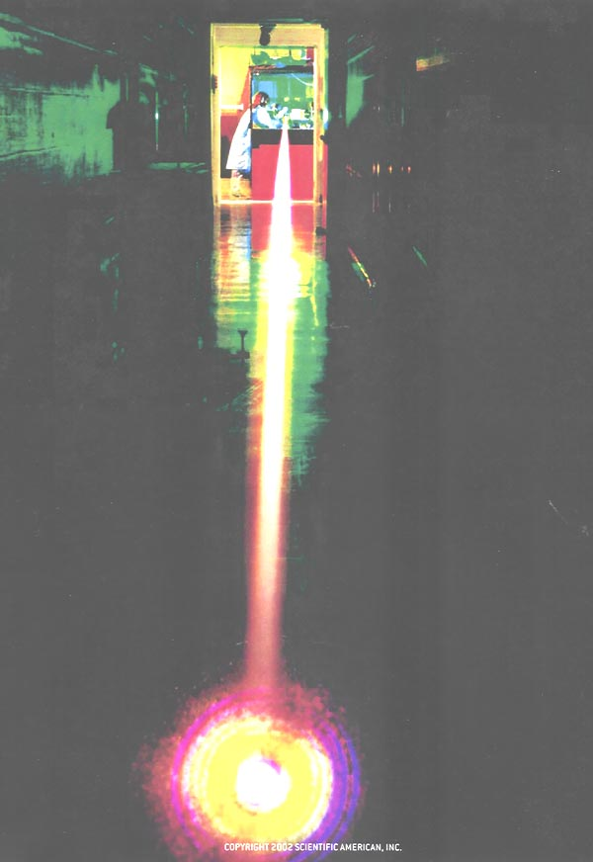

Overview/Extreme Light
■A method of laser amplification invented in the mid-1980s has enabled a new generation of tabletop lasers that produce very brief pulses of extremely intense light.
■Light of such high intensity interacts with matter in new ways, directly propelling electrons to nearly the speed of light in femtoseconds. The lasers can accelerate particles at 10,000 times the rate of standard accelerators.
■Potential applications include high-resolution medical imaging, inexpensive precision radiation therapy, nuclear fusion, and research in numerous subfields of physics.

The dream of intensifying light is as old as civilization. Legend has it that Archimedes focused the sun’s rays with a giant mirror to set the Roman fleet afire at Syracuse in 212 B.C. Although that story is a myth, it is true that around 200 B.C. another Greek, Diocles, had invented the first ideal focusing optic, a parabolic mirror. Two millennia later mirrors and quantum mechanics were put together to make the most versatile of high-intensity light sources: the laser.

The epitome of high-power lasers is Nova, which operated at Lawrence Livermore National Laboratory from 1985 to 1999. Named for the brilliance of an exploding star, Nova was one of the largest lasers ever built. Ten parallel chains of laser amplifiers occupied a 300-foot enclosure; mirrors made from 400-pound blocks of glass directed the beams to targets for nuclear fusion and other experiments. Nova was fired no more than a few times each day to avoid overheating. Clearly, it marshaled a lot of energy to achieve its ultrahigh power.

Yet power is the rate at which energy is delivered, so an-other approach to ultrahigh power is to release a modest amount of energy in an extremely short time. Nova’s usual pulses were relatively long by the standards of today’s ultrafast lasers -- three nanoseconds -- and each one required kilojoules of energy. By using pulses of one ten-thousandth their durations, a new type of laser that fits on a tabletop can deliver power similar to Nova’s [see “Ultrashort-Pulse Lasers: Big Payoffs in a Flash,” by John-Mark Hopkins and Wilson Sibbett; Scientific American, September 2000]. For example, an ultrahigh-power laser that delivers a mere joule in a pulse lasting 100 femtoseconds (10^{–13} second) achieves 10 trillion watts (10¹³ W, or 10 terawatts), more than the output of all the world’s power plants combined.

These compact lasers can fire a hundred million shots per day and can concentrate their power onto a spot the size of a micron, producing the highest light intensities on earth. Associated with these gargantuan power densities are the largest electric fields ever produced, in the range of a trillion volts per centimeter. Such intense laser light interacting with matter re-creates the extreme physical conditions that can be found only in the cores of stars or in the vicinity of a black hole: the highest temperatures, 10¹⁰ kelvins; the largest magnetic fields, 10⁹ gauss; and the largest acceleration of particles, 10²⁵ times the earth’s gravity.

Costing $1 million instead of several hundred million dollars, these lasers are helping to bring “big science” back to standard university laboratories and to countries with limited re-search budgets. Dozens of such systems have been built throughout the world in the past few years, for use in research in several subfields of physics, including nuclear physics, astrophysics, high-energy particle physics and general relativity. This new breed of laser has already spawned applications, such as x-ray lasers, ultra-compact particle accelerators and precision medical radiography. It also shows great promise for radiation therapy and improvements in nuclear fusion power generation.

The Trick
IN THE FIVE YEARS after the invention of the laser in 1960, tabletop lasers advanced in a series of technological leaps to reach a power of one gigawatt (10⁹ W). For the next 20 years, progress was stymied and the maximum power of tabletop laser systems did not grow. The sole way to increase power was to build ever larger lasers. Trying to operate beyond the limiting intensity would create unwanted nonlinear effects in components of the laser, impairing the beam quality and even damaging the components. Only in 1985 was this optical damage problem circumvented, with the introduction of a technique known as chirped pulse amplification (CPA) by the research group led by one of us (Mourou). Tabletop laser powers then leaped ahead by factors of 10³ to 10⁵ .

“Chirping” a signal or a wave means stretching it in time. In chirped pulse amplification, the first step is to produce a short pulse with an oscillator and stretch it, usually 10³ to 10⁵ times as long [see illustration on opposite page]. This operation de-creases the intensity of the pulse by the same amount. Standard laser amplification techniques can now be applied to this pulse. Finally, a sturdy device, such as a pair of diffraction gratings in a vacuum, recompresses the pulse to its original duration -- in-creasing its power 10 3 to 10 5 times beyond the amplifier’s limit. A typical example would begin with a seed pulse lasting 100 femtoseconds and having 0.2 nanojoule of energy. We stretch it by a factor of 10⁴ to a nanosecond (reducing its power from about two kilowatts to 0.2 watt) and amplify it by 10 orders of magnitude to two joules and two gigawatts. Recompressing the pulse to 100 femtoseconds increases the power to 20 terawatts. Without this technique, sending the original two-kilowatt pulse through a tabletop amplifier would have destroyed the amplifier -- unless we increased the amplifier’s cross-sectional area 10⁴ times and dispersed the beam across it. The CPA technique makes it possible to use conventional laser amplifiers and to stay below the onset of nonlinear effects.

Perfecting CPA was not as straightforward as it sounds. Typical devices used to stretch or compress pulses generally do not do so in an exactly linear fashion, and the result will be spoiled if the characteristics of the chirper and the compressor are not closely matched.

A further increase in light intensities has occurred in the past few years with the development of corrective optics that allow laser beams to be focused onto much smaller spot sizes. That advance and further improvements in pulse compression techniques have resulted in pulses that have the maximum possible intensity for a given energy of light.

These increases in power and intensity in the 1990s opened up a new regime of interactions between light and matter, known as relativistic optics, in which the light accelerates electrons close to the speed of light. Prior to CPA, this regime could be reached only by very large and expensive laser systems.

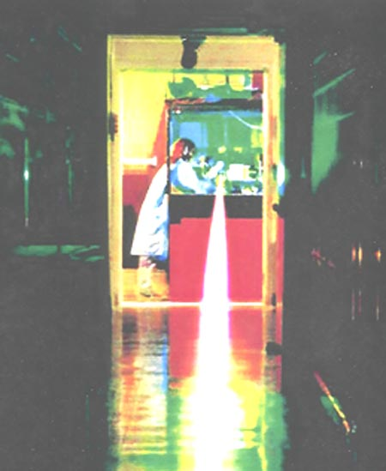

Tabletop ultrahigh-intensity lasers are bringing “big science” back to standard
university laboratories.

Relativistic Optics
OPTICS IS THE STUDY of how electrons respond to light. That definition may not sound like what many people think of as optics -- light reflecting off mirrors or being refracted by the water of a swimming pool. Yet all the optical properties of a material are a consequence of how light interacts with electrons in the material. Light is a wave composed of coupled electric and magnetic fields oscillating in synchrony at very high frequencies. The electric and magnetic fields oscillate perpendicular to each other and perpendicular to the direction the light is traveling [see illustration on page 6]. When an electron encounters a light wave of ordinary power, the electric field of the wave exerts a force on the electron and makes it oscillate. The electron oscillates parallel to the electric field and at the same frequency, but it does not necessarily oscillate in phase with the light wave. Depending on how the electron is bound to the atoms of the material, its oscillations may lag behind or lead those of the light wave. The amplitudes and phases of these electron oscillations in turn determine how the light wave propagates through the material and thereby confer on the material its optical properties.

In classical optics the amplitudes are small enough that the electrons’ oscillation velocities are always very small compared with the speed of light. With the advent of laser intensities above 10 18 watts per square centimeter, however, the electrons’ oscillation velocities approach the speed of light, and relativistic effects fundamentally change the electrons’ response to the light.

First, a high velocity increases the mass of an electron, which affects the amplitude and phase of its oscillations. More important, the magnetic field of the light wave starts to play a role. A magnetic field exerts a force on an electric charge only when the charge is moving. In the regime of classical optics the magnetic force is negligible. But for electron oscillation velocities near the speed of light, it curls the paths of the electrons and gives them tremendous momentum in the direction of the light beam. This effect plays a central role in relativistic optics.

The interaction of light with atomic nuclei can usually be ignored because protons are almost 2,000 times as massive as electrons and therefore oscillate much less. But at high enough intensities, the light starts moving protons around at relativistic velocities as well. That regime may be called nuclear optics because of the great variety of nuclear processes, such as fusion, that can occur.

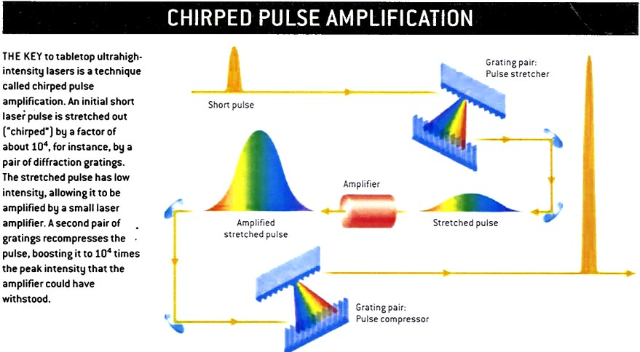

“0 to 60” (MeV) in a Millimeter

THE MOST OBVIOUS APPLICATION of the relativistic force of an ultra-intense laser beam is to accelerate particles. Charged-particle accelerators have numerous uses, ranging from television tubes to cancer therapy to the study of the fundamental forces of the universe. What they all have in common is that the particles, such as electrons or protons, are accelerated by electric or magnetic fields. Although light waves in the regime of classical optics can have electric fields as strong as those near bolts of lightning, these fields are not effective for accelerating particles on their own, because they oscillate transversely. In contrast, when an ultra-intense pulse of light strikes a plasma (a gas of electrons and positive ions), it propels the electrons for-ward close to the speed of light, as we described above.

That is not the end of the story. The plasma’s positive ions, being thousands of times heavier than the electrons, are left be-hind. This separation of positive and negative charges produces a large electric field, which can be used to accelerate other particles. The region of high electric field travels through the plasma as a wave, trailing in the wake of the light pulse. Charged particles are accelerated to high energy in laser wake fields just as dolphins gain energy by swimming in phase with the water wave in the wake of a ship. Such a laser wake-field accelerator was first proposed in 1979 by Toshiki Tajima and John M. Dawson, both then at the University of California at Los Angeles.

The process of converting the oscillating electric field of the light pulse into a wake field that points always in one direction is called rectification, by analogy with rectifiers in electronics that convert alternating current (AC) to direct current (DC). Conventional accelerators, such as the three-kilometer-long one at the Stanford Linear Accelerator Center (SLAC), use metal cavities to rectify radio-frequency waves to repeatedly “kick” charged particles along the beam line. (Radio waves are electromagnetic waves just like light but having much lower frequencies and longer wavelengths.) The Stanford accelerator has to be three kilometers long to achieve its target particle energies because the accelerating field of each cavity is limited. The field could be increased by using radio waves of shorter wavelength and greater intensity, but both of these properties are limited by the cavity: the cavity size limits the wavelength, and high intensities cause electronic breakdown (sparking) of the metal cavity walls. Laser wake-field accelerators avoid these limits by eliminating the cavity. With the highest-intensity pulses, particles might be accelerated directly, the same way that relativistic electrons are generated by the beam, allowing the plasma to be dispensed with.

In the past few years, laser-driven electron and proton accelerators have produced beams with energies greater than 50 million electron-volts (MeV), comparable to a single stage (a few meters long) of a conventional accelerator. The laser system achieves the same energy in a millimeter.

Prompt acceleration with high gradients has advantages. For example, one of us (Umstadter) has demonstrated electron beams of a few million electron-volts whose “brightness” (in essence, the concentration of particles in the beam) exceeds that of beams made by conventional accelerators, mainly because the charges bunched in one pulse of the beam have less time to blow it apart by its own electrostatic forces. In addition, researchers have shown that low-cost laser accelerators are suitable for many of the same applications as conventional accelerators, such as producing short-lived radioisotopes used in medical diagnostics and generating neutron and positron beams for studies of materials.

The laser systems create beams that have a relatively broad spread of particle energies, however, which is undesirable for some applications. Also, conventional systems routinely chain together numerous accelerator stages, as in SLAC’s three-kilometer collider and the seven-kilometer-circumference main ring of the Tevatron at Fermilab. Current research on laser accelerator systems is concentrated on reducing the beam’s energy spread and achieving multi-staging to increase the beam’s energy. Researchers are also exploring the use of waveguides to increase the distance over which the wake field keeps accelerating particles.
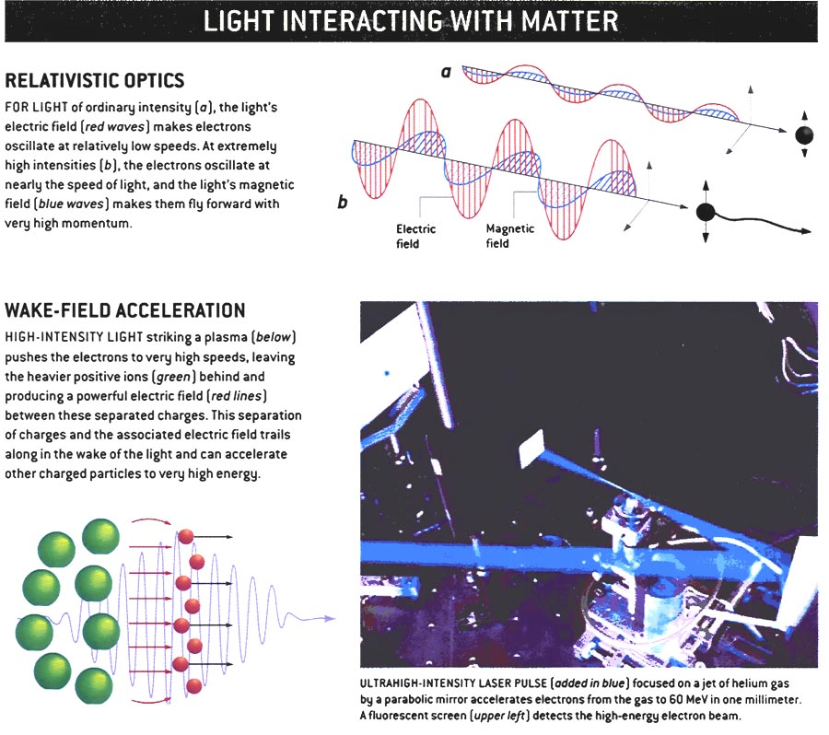

The High-Energy Frontier
WE DON’ T EXPECT laser accelerators to replace conventional accelerators at high-energy particle physics facilities such as the Tevatron. Rather they complement and augment present-day systems and have characteristics that make them useful for specific applications and new types of experiments. One such niche could be acceleration of unstable particles.

The Tevatron represents the high-energy frontier today: colliding protons with energies of a TeV. Its successor, CERN’s Large Hadron Collider, will also use protons. Such collisions are very complicated and messy because protons are agglomerations of strongly interacting particles called quarks and gluons. Electrons and positrons have a more elementary structure than protons and consequently produce much “cleaner” collisions, which allow more detailed, higher-precision studies. But accelerating them runs into a problem: the lightweight electrons and positrons lose too much of their energy to so-called synchrotron radiation as they travel around the curves of a circular accelerator.

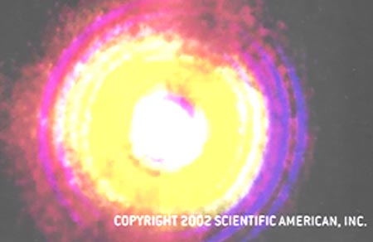

Small ultrahigh-power lasers might work like spark plugs, igniting thermonuclear fusion
at power plants.

One solution will be to accelerate muons, which are 200 times as heavy as electrons and thereby suffer synchrotron losses a billion times lower. Unfortunately, muons are unstable and decay in just over two microseconds on average. High-intensity lasers could be used to accelerate muons very close to the speed of light in a fraction of that fleeting lifetime. At that point, relativistic time dilation helps out, extending the muons’ lifetime in proportion to the energy achieved, providing more time for a conventional accelerator to take over. The benefit of prompt laser acceleration would be even greater for particles such as pions, which decay in a mere 26 nanoseconds on average.

Another new type of particle physics experiment enabled by ultrahigh-power lasers is the gamma-gamma collider. Gamma rays are extremely high energy photons or, equivalently, extremely high frequency light -- beyond x-rays on the spectrum. A high-power laser beam colliding with a high-energy electron beam produces a narrow beam of gamma rays. In essence, the laser’s photons rebound off the electrons in a process called Compton scattering. The energy of the gamma rays depends mostly on the energy of the electron beam: a 250-giga-electron-volt (GeV) electron beam knocks the photons from around 1 eV (visible light) to about 200 GeV.

When two such gamma-ray beams collide, the interactions are even cleaner than electron-positron or muon-antimuon collisions. The process is the reverse of matter-antimatter annihilation, in which particles merge and become a flash of radiation: instead pairs of particles and antiparticles burst into life out of a clash of photons. Only with ultrahigh-intensity lasers, however, are there enough photons in each pulse to produce a significant number of gamma-gamma collisions. In 1997 re-searchers from the University of Rochester, Princeton University, the University of Tennessee and SLAC demonstrated a variant of this system and produced electron-positron pairs by colliding gamma rays and laser photons. Today every linear particle collider has plans to conduct gamma-gamma experiments, which complement the research possible with the usual electron-positron collisions.

Finding and Curing Cancer
BY GENERATING highly penetrating radiation such as x-rays or particle beams, laser-driven charged-particle accelerators may also be used for cancer diagnosis and therapy. X-rays, of course, have been a diagnostic workhorse for a century. Conventional x-ray tubes accelerate electrons in an electric field that is set up between a cathode and an anode. When they strike the anode, the electrons are violently decelerated, which produces copious x-ray emissions. The resolution is limited by the size of the x-ray source, in this case the anode, which is generally about 100 microns across. The smallest tumor detectable by such a system is about a millimeter in diameter.

An ultrahigh-intensity laser can produce x-rays simply by be-ing focused onto an appropriate metal target. The beam accelerates electrons near the surface of the metal to high energies. These electrons are decelerated by their passage through the volume of the metal, once again emitting copious x-rays. Focusing the laser to a spot a few microns across makes an extremely small x-ray source, allowing detection of very small clumps of cancerous cells so that treatment can begin at a much earlier stage in a tumor’s development. In principle, resolution of a micron -- a little larger than the wavelength of the driving laser -- is possible. Research groups at Stanford University, Lund University in Sweden and the National Institute of Scientific Re search in Quebec have demonstrated these x-ray systems.
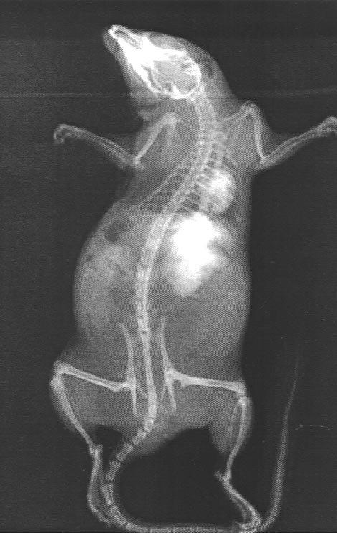

RADIOGRAPH OF A RAT shows the very high resolution that can be achieved by using x-rays generated from a tiny spot of plasma at the focus of a tabletop ultra-high-intensity
laser.

Precision is also of great importance for radiation therapy. The goal is to maximize the dose delivered to the tumor while minimizing harm to surrounding healthy tissues. When treating tumors in such sensitive areas as the brain or the spinal cord, the ability to deposit controlled amounts of energy in small, well-defined areas is critical. Particles such as protons and carbon ions are particularly well suited to this task. Unlike electrons and photons, these heavier particles suffer only minimal lateral scattering, so a beam remains narrow. The particles lose energy at a steady, very low rate along their track and then dump most of their energy at the end of it. For a specific initial energy, this occurs at a well-defined range through the tissue. Consequently, such heavier ions have much better accuracy than electrons and photons for delivering a dose to deep-seated tumors.

Clinical trials using proton and carbon beams are under way in several countries. One of the chief obstacles to wide-scale use of particle-based therapy, however, is the high cost of conventional particle accelerators. For example, the Heavy Ion Medical Accelerator in Chiba, Japan, cost almost $300 million to build. It can treat only about 200 patients a year, a small fraction of cases that could benefit from this form of cancer therapy. At the present time, laser-driven accelerators are able to achieve ion energies that are about a factor of five too low and have too great a spread of energies. But if those two problems can be overcome, ion radiotherapy of cancer will be possible at much lower cost and thus available to many more patients.

A pulse from an ultrahigh-intensity laser delivers as much power as all the world’s power generators. In the future, that equation may be turned around, with such lasers becoming an essential component of nuclear fusion power plants supplying some of the world’s power needs. Controlled nuclear fusion for power generation has been pursued for decades and has remained frustratingly out of reach. A method that has gained favor in recent years is inertial-confinement fusion, in which capsules of fuel -- such as mixtures of deuterium and tritium (heavy isotopes of hydrogen) -- are hit from all sides simultaneously by dozens or hundreds of intense laser pulses. The lasers compress and heat the capsules to the extreme densities and temperatures at which the deuterium and tritium nuclei fuse together to form helium and release large amounts of energy. The huge Nova laser at Livermore was one of the leading experimental devices used in research toward that goal.

Tabletop ultrahigh-intensity lasers cannot supply enough total energy to drive thermonuclear fusion, but in conjunction with their Nova-size cousins, they may bring the process much closer to economic and technical feasibility. Achieving the conditions needed to ignite fusion by compressing the capsules requires an extraordinarily symmetrical implosion process. The tiniest imperfections lead to worthless fizzles. In the new technique, proposed by researchers at Livermore, the large lasers will still do the hard work of compressing the fuel to high density but do not have to achieve the full ignition temperature as well. Instead, near the point of maximum density, an ultra-short pulse of ions accelerated by a compact, ultrahigh-power CPA laser strikes the imploding capsule, playing a role like a spark plug in a car engine: the pulse creates an intense hot spot, igniting a wave of fusion that burns across the rest of the pellet. This technique should reduce the immensely difficult technical requirements of igniting fusion by implosion alone, and it should significantly increase the ratio of energy produced to energy used.

Some of the fundamentals of the fast-ignition technique were recently demonstrated by researchers from Rutherford Appleton Laboratory in Oxfordshire, England, and Osaka University in Japan. But as is always the case in fusion research, much more must be accomplished to prove the method’s practicality for economic power generation. Whether or not that particular application becomes the stuff of legend, ultrahigh-intensity light has a future that is spectacular and diverse beyond the wildest dreams of Archimedes and Diocles.

THE AUTHORS

GÉRARD A. MOUROU and DONALD UMSTADTER were among the founders of the National Science Foundation–sponsored Center for Ultrafast Optical Science at the University of Michigan at Ann Arbor. Mourou, the director of the center, is a professor of electrical engineering, and Umstadter is an associate professor of both nuclear and electrical engineering. When they are not accelerating particles with intense lasers, they can be found accelerating down ski slopes to “ultrahigh” speeds.

MORE TO EXPLORE
Terawatt Lasers Produce Faster Electron Acceleration. D. Umstadter in Laser Focus World, pages 101–104; February 1996.
Ultrahigh-Intensity Lasers: Physics of the Extreme on a Tabletop. G. A. Mourou, C.P.J. Barty and M. D. Perry in Physics Today, Vol. 51, No. 1, pages 22–28; January 1998.
Review of Physics and Applications of Relativistic Plasmas Driven by Ultra-Intense Lasers. D. Umstadter in Physics of Plasmas, Vol. 8, No. 5, pages 1774–1785; May 2001.
High Field Science Research at the University of Michigan Center for Ultrafast Optical Science: www.eecs.umich.edu/USL-HFS/

