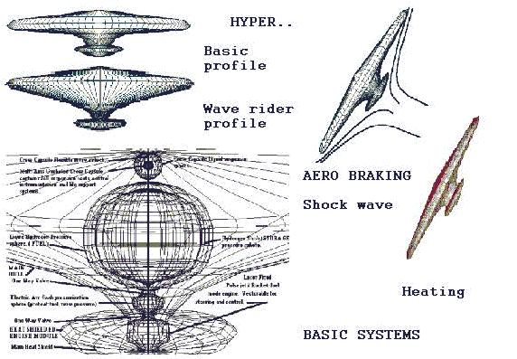  LTAS HYPER  Single Stage To Orbit craft.  Using Ionic/ EK boundary layer control and Laser Fired Duel mode engine system. (PP) 1979 LTAS | 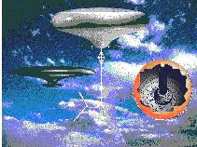  S.O.S.C.S platform, HYPER SSTO craft and S.O.L.D. orbital launch system. From  “Slowly Up the High Road…  Airships to Orbit.” © 1998 LTAS | 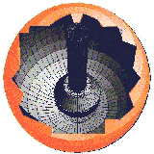  LTAS Sub Orbital Launch Device (SOLD)  Able to launch 6 DC-X class units form stratospheric altitudes.  (PP) LTAS
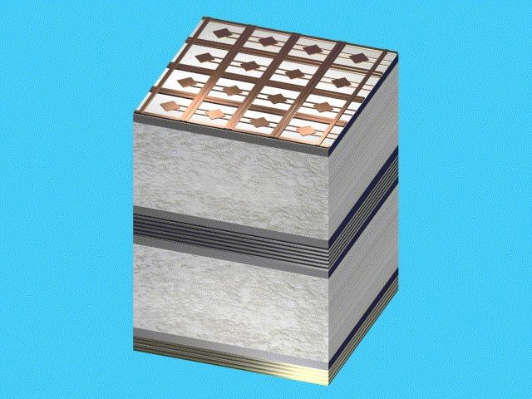  LTAS MK-4 Ionic / EK hull panel  Included propulsion, power storage and power generation layers as well as hull structure.  (PP) LTAS | 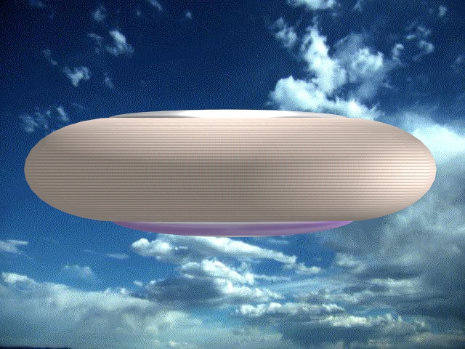  (Side view) LTAS craft using  MK-4 hull panels for propulsion, boundary layer and sonic shockwave control.  (PP) LTAS | 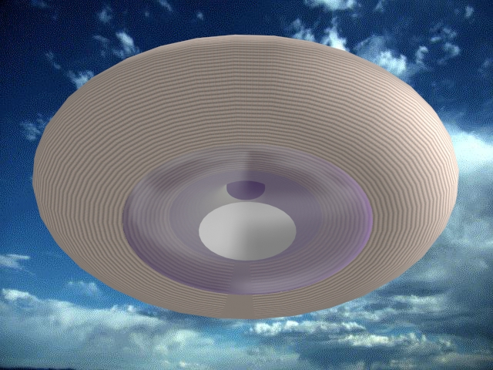  (3/4 Bottom view) LTAS craft using MK-4 hull panels and LTAS “infinite edge” hull form.  (PP) LTAS
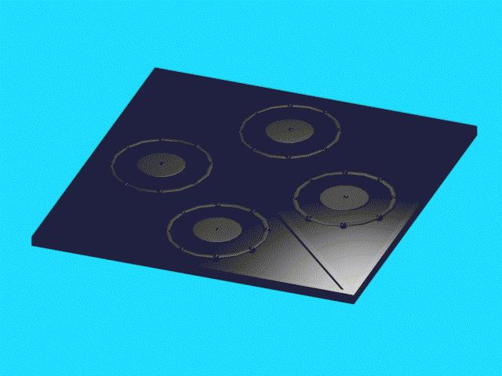  LTAS MK-5ionic/EK hull panel. Includes all features of the  LTAS MK-4 panel.  (PP) LTAS | 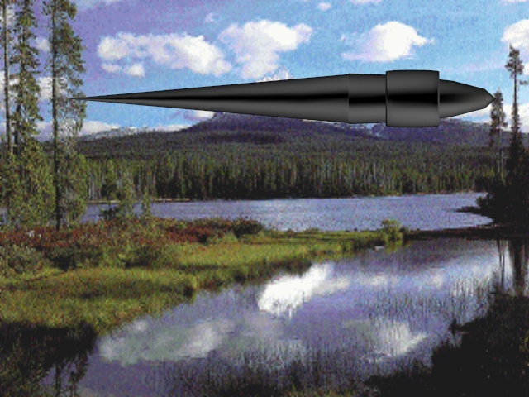  LTAS “Black Triangle” SSTO craft using LTAS MK-5 hull panels (PP) LTAS | 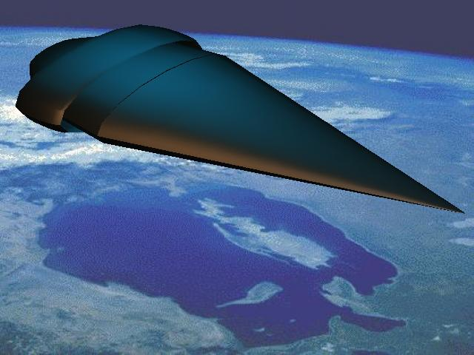  LTAS “Black Triangle”  in LEO after SSTO using LTAS MK-5 hull panel.  (PP) LTAS

LTAS ADVANCED IONIC / EK HULL PANELS AND PROPOSED LTAS CRAFT.

