ADVANCED LIFTER TECHNOLOGY
As an inventor, I couldn’t care less whether or not the idea for the technology
came from a crashed UFO. To be perfectly honest, I’m not what you would call a
“believer” anyways, although I have often wondered about it. My point is not to
attempt to lend any credibility to “Art’s Parts”, but rather to tie in the properties of
the anomalous material’s high-voltage movement with the underlying theory of
lifter operation.
Even mentioning a UFO in a respected publication or article is the kiss of death
in today’s world – and I wouldn’t do it if it wasn’t an intricate part of the story. The
other interesting thought is that the layered material is once again partially
composed of Bismuth – which is thought to possibly have some of the same
electro-gravitational properties as Bob Lazar’s Area 51 “element 115”. Is there a
similarity, or merely a coincidence between a claim that hasn’t gained credibility
and a technology currently under development?
The lifter in its own right is essentially a layered material. One of those layers is the emitter wire, which is highly charged with about 30kV worth of electrons, another layer is the air-gap, which is approximately 3 cm in height, and the final layer is an electrically-grounded “skirt” of aluminum foil that surrounds the lifter. It is also reasonable to expect that there are only two possible forces at work in the lifter – one of which being a possible ion-wind effect moving down from the emitter to the foil, and the other being a possible Biefeld-Brown effect, moving up through the foil to the emitter.

There are a few shortcomings in the lifter as a design that might be overcome if we could transition the layered material from one containing an air-gap to one that does not.
For instance, the lifter is currently a rather delicate object, in that
having a wire under tension as the emitter makes construction difficult for future
automated assembly. Additionally, because the air-gap requires struts to support
the emitter wire, a trade off involving the weight versus the strength of the struts
is additionally involved in any current implementation of lifter technology.
Some of the other changes that would be helpful to implement when transitioning
lifter technology from one type of air-gap to another are changes in the materials
used to increase the dielectric capacity. High-K dielectric materials may be used to increase the displacement of electrons in the material to enhance charge transport. And since increasing the dielectric potential of the layered materials also increases the breakdown resistance, it means that thinner materials can be used.
Designing a lifter without an air gap would accommodate lower voltage
requirements between the foil and the emitter. The voltage would not have to create the large e-field gradient to create a leakage current across such a large void. Therefore the overall voltage across the device could be greatly reduced, without much cost in thrust. A lower operating voltage in turn means that a lower output power-supply can be used for a given amount of current, which increases the overall efficiency.

Transdimensional Technologies recent research is utilizing the layered materials approach to eliminate the air-gap and substitute for it high-k dielectric materials that may allow higher overall performance. Although they have not yet released details about the exact composition or thickness of the materials that they are working with, they claim to currently have a 10% reduction in weight using a low voltage current across the thickness of their newest device.

** At least 3 different versions of this “integrated lifter / hull technology” have already been designed!! Both their “theory and practical use” has been known for over two decades. Recent works have clarified the underlying theory but do not represent any improvement in the operation of the actual devices.

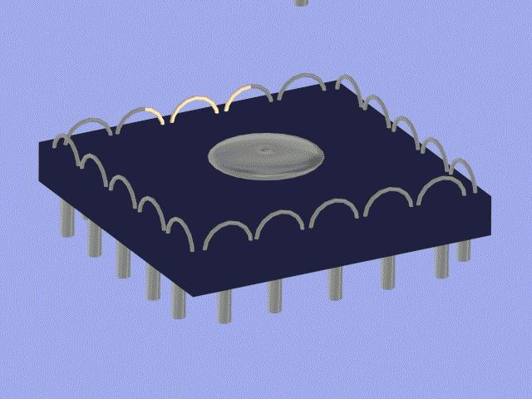  LTAS ion panel 3 | 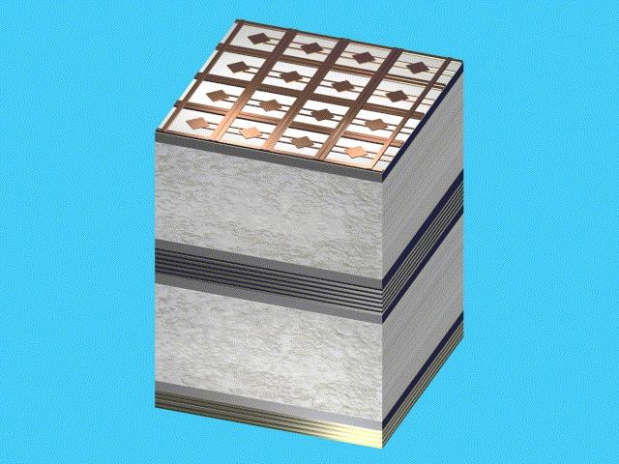  LTAS ion panel 4 | 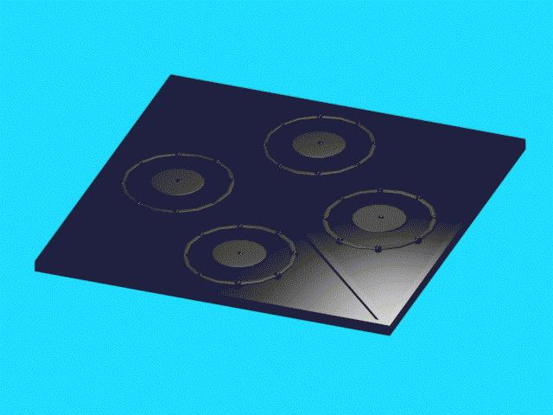  LTAS ion panel 5 | 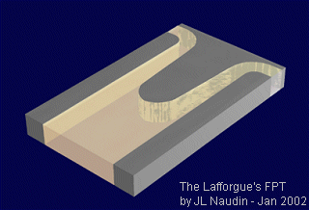  Lafforgue's Field Propulsion Thruster

See…
http://jnaudin.free.fr/lfpt/index.html

As can be seen, the current “improved Biefeld-Brown apparatus” experiments

See…
http://jnaudin.free.fr/html/enhbbexp.htm

AND the Lafforgue's Field Propulsion Thruster “curve geometry”
http://l2.espacenet.com/dips/bnsviewer?CY=ch&LG=fr&DB=EPD&PN=FR2651388&ID=FR+++2651388A1+I+

both bear a strong operational and geometrical likeness to the previously developed MK-5 LTAS ionic hull panel. (PP) LTAS **

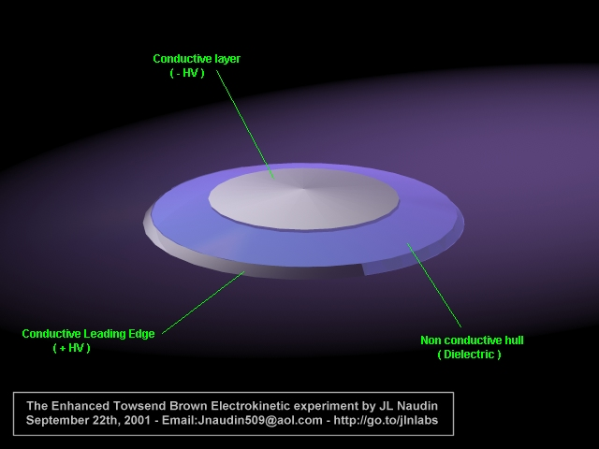  Enhanced TT Brown apparatus. 2000 | LTAS MK-5 integrated hull / ion panel | 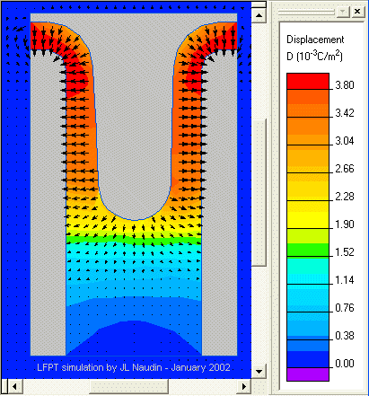  Lafforgue's Field Propulsion Thruster “curve geometry”

We note that both complete boundary layer control, ionic / B-B propulsion, and supersonic shockwave control are inherent in craft using such “hull panels” in their construction as shown in the following papers…
- AIAA 6th Aerospace Sciences Meeting " Electroaerodynamics in supersonic flow" by M.S.Cahn and G.M.Andrew from Northrop Coporation - N°68-24 January 22-24, 1968.
- US Patent N°3446464: Method and apparatus for reducing sonic waves and aerodynamic drag from William A.Donald, May 27, 1969
- AIAA 3rd Fluid and Plasma Dynamics conference" Recent experiments in supersonic regime with electrostatic charges" by M.S.Cahn and G.M.Andrew from Northrop Coporation - N°70-759 June 29-July, 1970.
And recent replications….

http://jnaudin.free.fr/html/ehdaero.htm

“ The tests definitely show that it is possible to modify the airflow and shock structure of a body by electrodynamics.... The tests have proven that electronic charges have considerable effect on supersonic flow. At Mach number 1.4, large changes in shock wave structure were caused using moderate power..... When about 10 to 15 kilovolts were applied to the rod in DC100 there was a large effect on the shock pattern.... Visual observations from the liquid surface indicated that the overall shock pattern was significantly flattened out.”
One might also note that the ionized layer created by such a paneled craft not only allows for “silent” flight at supersonic speeds, but also causes radar and visual difficulties.

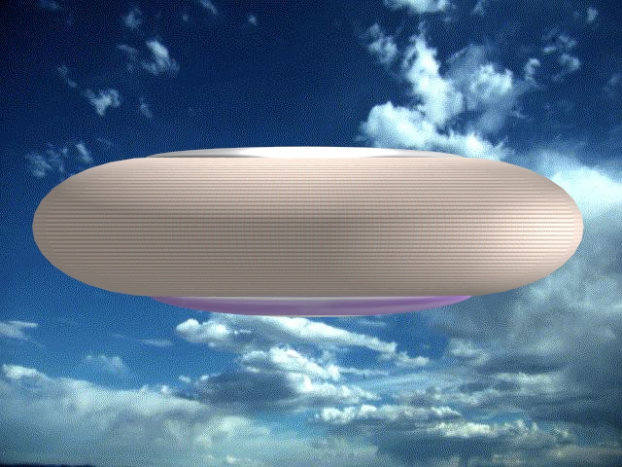  LTAS MK-4 ionic / EK hull panel craft  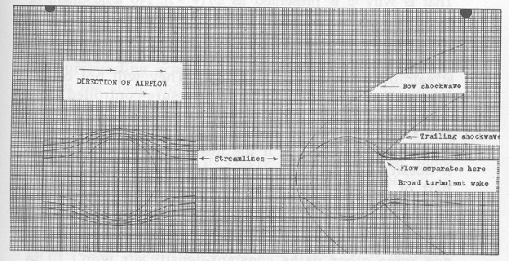  Shockwave effects on slipstream. | 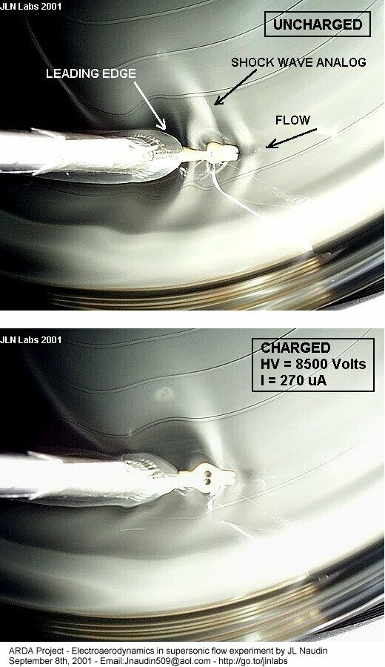 | 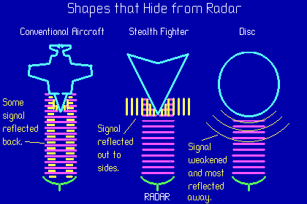  Radar returns of different forms.  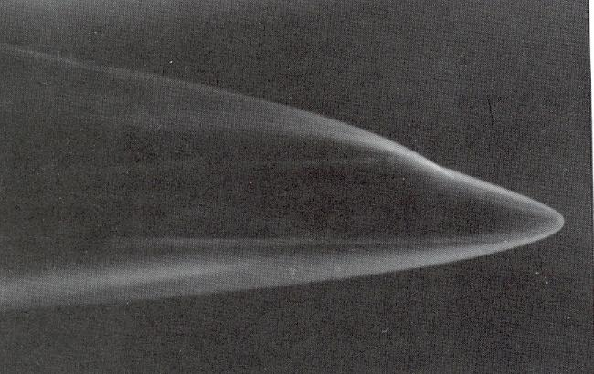  Visual effect of surface ionic airflow on sighting of aircraft.

FUTURE LIFTER TECHNOLOGY

Thanks to the tremendous amount of research being done on lifter technology by
Transdimensional Technologies and a loosely affiliated group of inventors around
the world, the future of lifter technology seems very bright at this point.
Transdimensional hopes to release some breakthrough research to allow
replication of their newest 2nd generation experiments in the very near future, and
along with that stands the massive body of research and advancements being
done by inventors and researchers such as Jean-Louis Naudin, Saviour, the
Lifters-group, and myself.

My personal goals are to attempt to assist Transdimensional Technologies in
popularizing this technology to increase awareness of it and help “spread the
word” about what it is and how it can potentially help the world.

Imagine if instead of getting in your car and driving through the usual maze of thoroughfares and side streets you were able to simply type in your destination and have a flying vehicle take you there automatically. The lifter technology offers to potential to transform the current transportation market by offering pointto- point aerial transport without the need for roads or freeways.

Additionally, unlike the magnetic-levitation (“Maglev”) technologies that are
currently being promoted as the future of transportation, the lifter does not
require a specially constructed and exorbitantly expensive track to operate – the
greatly reduces the per-unit cost on the technology and opens the door for wider
adoption by the general public for transportation solutions.

Other individuals are currently working to see if lifter technology may offer cost effective methods of transport into space, which would reduce the cost greatly and allow a one-piece, reusable method of moving things into orbit.

**A long held dream by many. I have designed a number of craft for both in atmosphere and SSTO/Space flight using aspects of my ionic / EK drive systems. My paper “Slowly Up the High Road…Airships to Orbit.” and other articles I have written Include a number of these proposed LTAS (PP) systems. **

