The Evolution of Lifter Technology
By Tim Ventura [tventura6@attbi.com]

** Additional commentary by M.K. Walden 2002 **

INTRODUCTION
Readers of the electric-spacecraft journal might know a little about the Lifter
technology popularized most recently be Jean-Louis Naudin, but they probably don’t know the whole story.

** Indeed, a lot less than even you suspect… **

In the short amount of time that has transpired since the publication of that article, this technology has both literally and figuratively taken off – going from a “proof-of-concept” prototype by Naudin to an international group of researchers investigating how to give the lifter higher-performance and greater efficiency. With the first commercial products now on the horizon, if you haven’t taken the time to read up on lifter technology, this is the perfect time to do so. . . To give you a complete up-to-date overview of where this technology is, where it is going, and what I think it is capable of, let me start with the basics – an overview of how I became involved with Electrogravity research and what eventually led me to become involved with lifter technology.

MY BACKGROUND
I started college at 16 years old, back in 1992 – at the same time, I purchased a
kit containing “hoverboard plans” from Hovertech, Inc. The moment that I
received that $20 white-manilla envelope in October 1992 was the moment that I
became involved with what has now been nearly 10 years of electrogravity
research. I worked with Bill Butler – the president and chief-scientist of Hovertech – on a variety of different antigravity, Electrogravity, and levitation ideas from approximately 1992 through 1996. While putting in my college time, I was also taking distinct advantage of the enormous college library at Western Washington University to read up on everything that might possibly relate to Electrogravity. I read books on standard electronics and physics theory alongside with books by the masters of this science, such as TT Brown and Nikola Tesla.
Bill and I played with several different ideas – many of them only peripherally
related to Electrogravity. For instance, I published a manuscript initially in 1996
describing Tesla’s theory on how to reliably produce Ball-Lightning using a
standard Tesla coil – the information courtesy of WWU’s excellent library. Bill
also assisted me with obtaining video footage of a Searl-effect conference that
he attended in Denver in the early 90’s – this footage was an excellent overview
of Searl’s design and construction concepts for what he believes is the next
major technological step in aviation and space travel. Bill and I eventually found different paths, and in some ways drifted apart. Bill moved into Geomagnetic levitation research and started intense investigation on the patents of How Wachspress and the magnetic dipole levitator. I went to more traditional technologies – eventually becoming a UNIX system administrator for AT&T Wireless. I hadn’t heard from Bill Butler in about 6 months when he sent me a short email containing the words “hey, check this out” – and a link to Jean-Louis Naudin’s “Lifter Experiments” home-page. I visited the site, watched all of the video clips, and then watched them again. This was the technology that I had been waiting for!

** After taking degree programs in literature (Berkley, UC Santa Cruz), Aeronautical engineering (Stanford, UN Reno), Electronic engineering, Solar technologies and Computer science (CCSN, UNLV), I eventually ended up as the computer facilities manager in the Nevada University / college system.

For over 30 years I have been working in LTA flight including craft with solar electric, solar hybrid, Laser fired pulsed rocket/jet, ionic wind and electrogravitic / electrokinetic propulsion systems. Patent application for many of these systems were made during the 1970s. I am Historically recognized as having flown the FIRST composite rigid monocoque hulled solar powered airship in 1974. Working demonstrations and models of many of these systems were done for the US Department of Defense and US Department of Energy at Nellis Air Force Base in Southern Nevada in 1977.

The XEM-1 was also the FIRST demonstrated SELF POWERED / SELF CONTAINED FLYING MODEL OF A BIEFELD-BROWN EFFECT POWERED AIRCRAFT **

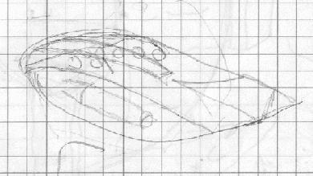  XEM-1 drawing 1969 | 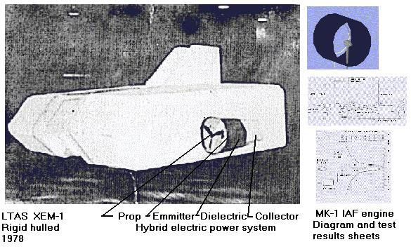  XEM-1 model Mk-1 engine and test data 1970s | 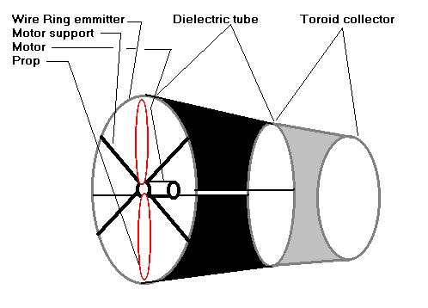  XEM-1 hybrid ionic airflow duct 1970s

See….
http://www.lvcm.com/walden Click “history” See “ionic airflow engine”

and…

http://www.scsv.nevada.edu/~walden/tech1.html

LIFTER TECHNOLOGY
I can say without a doubt that the lifter technology is completely revolutionary, but you might not realize how profoundly revolutionary it is until you’ve stopped to
think about it for a bit. What is it about the lifter that makes it so unique,
especially when so many inventions claim to produce more and better
electromagnetic thrust? The answer is simple – the lifter works repeatedly.

** While this may be how it appears to THOSE NEW TO THE FIELD, it is quite evident to “one skilled in the field” that the “Lifter technology ” is not revolutionary at all !!
So called “lifter technology” units have been flown “repeatedly” for nearly 80 YEARS !! ANYONE who claims to have “invented it or developed it” in the last 40 years has not done their “homework” as even the so called “advanced” versions of recent “lifter experiments” are ONLY replications of past units and experiments done long ago. **

http://jnaudin.free.fr/html/enhbbexp.htm
Jean-Louis Naudin started a figurative bonfire when he decided to replicate a
“proof-of-concept” experiment by a small Huntsville, AL aerospace contracting firm.

** Hardly a “Proof of concept” as Jean-Louis points out in the main page of the “lifter project” … “ “ this is JUST another successful test of the B-B system. I also find it interesting that I had been in contact with the Huntsville Al. L-5 society on their "Project HALO High Altitude Lift Off" system for several years

See…
http://home.hiwaay.net/~hal5/HALO/index.shtml

Contact: Ronnie Lajoie
HAL5 Project HALO Press Site Manager
Daytime Phone: 256-461-5934
Evening Phone: 256-721-1083
FAX Phone: 256-461-3045
Primary E-mail Address: hal5@hiwaay.net
Alternate E-mail Address: Ronnie.M.Lajoie@boeing.com

even sending them a copy of my paper "Slowly Up the High Road…Airships to Orbit." (Published ASES SOLAR '98 © 1998) Which details the use of both Laser fired rocket engines (HYPER) and the ionic drive for an LTA high altitude launch platform (SOLD)…. As this is another claim by Transdimensional Technologies **

See… **
http://www.ecotopia.com/ases/fueltran/

and

http://www-aero.meche.rpi.edu/Curriculum/TAVD/

Magnetocaloric Hybrid Rocket Engines
The addition of a ferromagnetic material to the fuel grain increases the performance of a hybrid rocket engine above that added by chemicals, by using the energy in the magnetic field. During the combustion process, the magnetic field gives up energy in the form of heat. This is observed as an increase in temperature, pressure, and hence ISP without an increase in mass.

Odyssey
An aeroshell filled with helium will be the first stage of a launch vehicle. It will carry the second stage into low earth orbit. The second stage is a small rocket that lifts the payload to the desired altitude. The vehicle will be launched from a movable sea platform. A remote laser beam in conjunction with a Laser Accelerated Vaporization Reactor will boost the aeroshell to higher altitudes. This reusable vehicle can carry payloads to LEO or loiter at high altitudes for remote sensing or military applications.

The lifter initially came into being in the mind of Jeff Cameron – the chief
scientist of Transdimensional Technologies – in the 1970’s

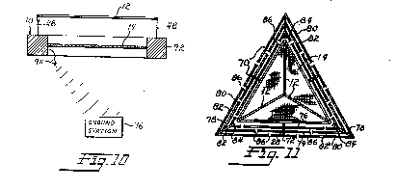 | 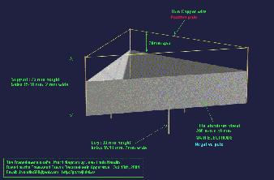

** Hardly….. To Quote Mr. Ventura's web site on some of this "prior art".

See…

http://americanantigravity.com/deseversky.html

" Ion-Wind Effect
Ion-wind devices seem to exhibit considerably lower ratios of efficiency that do more conventional aircraft, such as an airplane or helicopter. Ion-wind vehicles to make up for this lack of power in terms of simplicity of design and the general lack of complex mechanical systems -- there are two areas in which no conventional aircraft is comparable to the solid-state ionocraft.

http://www.keelynet.com/gravity/majorde.htm

Biefeld-Brown or Ions?
The Lifter has been under considerable scrutiny with regard to whether it is an ion-wind technology or in fact a method of pure field-effect propulsion that somehow "claws its way forward" through the quantum vacuum.

For the moment, it appears that the distinction between ion-wind and Biefeld-Brown technology is almost arbitrary in nature -- the real distinction between the two becomes apparent in a vacuum environment, where ion-wind ceases to function but Biefeld-Brown should function normally (if the theory is accurate). "

** In reading both the original T.T. Brown patent data (1928-1960) and the original IONOCRAFT patent data it quickly becomes obvious that BOTH units (And BOTH were developed WELL BEFORE either the lifter concept from Transdimensional Technologies in the 1970’s or the NASA "Apparatus & Method for Generating Thrust Using a Two Dimensional, Asymmetrical Capacitor;" patent granted in 2001,which are IDENTICAL to the prior experimental units and indeed cruder versions of the SAME units and concepts.

To also Quote the main "modern" lifter web site…

See… **

http://jnaudin.free.fr/html/lifters.htm

" On June 2001, Transdimensional Technologies has presented the Lifter1 and Lifter2 devices. These devices are able to lift their own weight and they are a "modern version" of the Townsend Brown Electrokinetic Apparatus. The Lifters are using the Biefeld-Brown Effect to generate the main thrust to self levitate. " **
NASA has stated…
" For your information, here is a revised standard reply regarding inquires into any of the following (which are all variations of the old Biefeld-Brown effect):
- Biefeld-Brown
- Asymmetrical Capacitors
- Lifters
- Electrokinetics
- Electrogravitics (this term also used for other things)
- Field Propulsion (actually a broader term)
Enjoy,
Marc G. Millis
Researcher, NASA Breakthrough Propulsion Physics Project
NASA John H. Glenn Research Center
========================================================
Since the NASA Breakthrough Propulsion Physics (BPP) Project receives so many inquiries about this one effect, the following standard reply has been prepared.
VARIOUS NAMES FOR THIS EFFECT:
- Biefeld-Brown
- Asymmetrical Capacitors
- Lifters
- Electrokinetics
- Electrogravitics (this term also used for other things)
- Ether Propulsion
- Field Propulsion (misuse of broader term)
- Antigravity (misnomer)
The NASA Breakthrough Propulsion Physics (BPP) Project is aware of a variety of work on "asymmetrical capacitors," "Lifters," or other variations of the old Biefeld-Brown effect. At least five different groups are working on this effect. Regrettably, most of these groups have focused on promoting their claims through web sites, press conferences and patents, rather than on publishing credible, experimental results in peer-reviewed scientific literature. Such an emphasis on marketing over reliability is tainting the topic with sensationalism and is not providing the information needed to accurately resolve the unknowns.
Presented here is a brief description of the effect (with references) and recommended next steps.
DESCRIPTION OF EFFECT:
The "Biefeld-Brown" effect claims anomalous thrust from unusually shaped capacitors that are charged to high-voltage. The claims are often touted as "antigravity" devices or as the discovery of some other new physics, despite the fact that credible investigations have concluded that ion wind is being misinterpreted as the mysterious force. It is quite easy to get visible thrust from ion wind effects.
Most of the original documentation comes from Thomas Townsend Brown, over the period of 1950-1973. Some patent numbers for the Brown's "electrokinetics" include, 2,949,550, 3,022,430, 3,187,206, 2,949,550, & 3,018,394.
There are, however, still some unresolved issues. Specifically, during the Talley tests (ref. below), anomalous forces were observed during the on/off transients -- anomalies that were never resolved. Also, the "folk lore" on the topic suggests that the "real" effect will not appear unless the voltage is above 14 kV and when there is a slight current leakage across the capacitor.
For a credible assessment, study this report:
-------------------
Talley, R .L., (Veritay Technology, Inc. East Amherst NY), Twenty First Century Propulsion Concept, PLTR-91-3009, Final Report for the period Feb 89 to July 90, on Contract FO4611-89-C-0023, Phillips Laboratory, Air Force Systems Command, Edwards AFB, CA 93523-5000, (1991).
-------------------
In addition, this more recent conference paper demonstrated that the effects could be traced back to corona wind phenomena.
-------------------
Tajmar, M., "Experimental Investigation of 5-D Divergent Currents as a Gravity-Electromagnetism Coupling Concept", in "Proceedings of the Space Technology and Applications International Forum, (STAIF-2000)," El-Genk editor, AIP Conference Proceedings 504, American Institute of Physics, New York, 2000, pp. 998-1003.
-------------------
REQUIRED NEXT STEPS:
There has not yet been RELIABLE, IMPARTIAL, and TESTABLE DATA published on such claims (Capitalization for emphasis) that resolves the remaining issues. A credible, objective, peer-reviewed publication about the unresolved experimental observations of this effect, written with sufficient detail for independent replication, is needed. To be reliable, such publications must also address the variety of conventional effects that might incur misinterpretations, such as ion wind, corona discharges, electrostatic interactions, etc.
In future calls for proposals or papers on this topic from the BPP Project, the judging criteria places a greater emphasis on the reliability of the results than on the viability of the effect. The first researcher who succeeds at producing a peer-reviewed article on this topic will have a noteworthy advantage in any future solicitations on this effect.
Until this is done, this Biefeld-Brown subject and its variants will still be considered as mostly non-credible research.
NEWS (May 2002) :
Recently, the West Virginia Institute for Software Research, operating under a Congressional earmark, has offered to conduct an independent, experimental assessment of the "Asymmetrical Capacitors." This task, managed by Gary Johnson of NASA's Marshall Space Flight Center, will test the rotational and linear motion configurations under various vacuum conditions at West Virginia University later this summer.
* * * * *
------------------------
Marc G. Millis
Researcher, NASA Breakthrough Propulsion Physics Project
NASA John H. Glenn Research Center at Lewis Field
21000 Brookpark Rd., MS 86-2
Cleveland, OH 44135-3191
Breakthrough Propulsion Physics PROJECT site:
http://www.grc.nasa.gov/WWW/bpp/
"

** Of course this begs the question… Just how does NASA claim a patent on a technology that they admit is IDENTICAL IN FUNCTION AND EQUIPMENT TO 80 YEARS OF PRIOR ART, and to concepts that EVEN NASA DOES NOT HAVE
" RELIABLE, IMPARTIAL, and TESTABLE DATA published on such claims (Capitalization for emphasis) that resolves the remaining issues. " YET ???

NASA has tested work on these systems by “well known world experts” in the field of “corona ion engines” (read “ ion wind”) who they “use” in other NASA programs.. ie….

http://www.physics.ucla.edu/faculty/ladder/wonga.html

At worse NASA is going to spend our money "Studying" something that ALREADY WORKS! (ie NASA's "revolutionary projects development funded projects of 1999…."blended wing bodies" (Northrop flying wing 1930s, B2 bomber ), "Deltoid hybrid LTA vehicles" (Aereon manned deltoid airships 1960s), Pulsed detonation engines" (V1 1930s and LTAS HYPER L.F.P.D. engine 1970s). NASA will then try to "license" it to us for "commercial use" while the Government gets to use it for free. (Avoiding royalties to the original inventors and patent holders )

See…

http://technology.nasa.gov/scripts/nls_ax.dll/twDispTOPSItem(111;TOP8-80;0;1)
Technology Commercialization Status
Protection - Patent #6,317,310
Prototype - A proof-of-principal model is available.
Licensing - Licenses are available for all fields of use.
Knowledge Transfer - Inventor is available for assistance to license.
Contact
If your company is interested in this technology please contact:
Sammy Nabors
NASA Marshall Space Flight Center
M.S. CD30
George C. Marshall Space Flight Center
MSFC, AL 35812
Phone: (256) 544-5226
FAX: (256) 544-3151
E-mail: sammy.nabors@msfc.nasa.gov
At best, the basic TT brown patents and ALL BASIC Biefeld-Brown effect Heavier than air versions of the "lifter" are in the public domain. Meaning they can be used WITHOUT LICENSE FEES to NASA or anyone else.

Indeed, since I have been flying aircraft employing these technologies for over two decades BEFORE the NASA patent application and hold patents pending on a number of “improvements” in the field I certainly have no intention of paying NASA any fees !! **

from experiments conducted with high-power military and research-grade lasers. A device in the lasers called a “pre-ionizer” was used to apply a high-voltage to the lasing medium to facilitate better performance. Repeated operation of the pre-ionizer had a common side-effect of horribly twisting the wire and foil combination out of shape, which required a decent amount of work to repair.

Jeff Cameron realized that the torsional effect on the pre-ionizer was a side effect of some unknown force acting on the pre-ionizer apparatus, and he began a long-term investigation into what was causing the apparatus to deform. His eventual results indicated that a force in the foil collector in the pre-ionizer was causing a net-thrust in the entire pre-ionizer apparatus that was making it twist and move on its mounts within the laser – the lifter came to him later as a three dimensional device to demonstrate this force.

Naudin’s genius became readily apparent not through a giant breakthrough in
technology, but rather in a more subtle fashion – he replicated the lifter
experiments of Transdimensional Technologies and published videos, articles,
and complete construction plans on his website to allow others to do the same. In
a manner similar to the open-source software movement, Naudin had taken an
incredible scientific find that might have otherwise been overlooked and done and incredibly charitable and intelligent thing – he gave it away for others to play with. By following Naudin’s instructions, inventors all over the globe began to
slowly replicate the Transdimensional Technologies experiments and thereby
validate the proof of concept that Jeff Cameron had created to show that his
“mystery force” was real after all. Naudin of course took advantage of these
replications of the experiment by showcasing them on his own website – which in turn lends additional credibility to his research.
As far as technology goes, the lifter demonstrates that science and engineering have more than their share of humorous irony. For the years that I researched Electrogravity and antigravity claims, all of the devices that I had seen required something “magic” to make them work. For instance, Bob Lazar’s UFO-claims could have been reverse-engineered except that they require ‘element 115’ to make them work – an element chemically related to Bismuth that is theorized to potentially have electrogravitic properties. I will come back to the possible electro-gravitational properties of Bismuth in a bit, as it turns out that this element may in fact provide some use for future lifter technology.
The Searl-effect disc is an even better example of the “magic” usually involved
with building a working Electrogravity device. Searl’s ideas seem valid enough,
but although he supposedly demonstrated several working prototypes in the 1950’s, he is currently pursuing millions of dollars in research funding in to replicate those experiments in a modern-day setting.
** Of course the Keelynet article says that TT is doing pretty much the same thing as NASA ….

http://www.keelynet.com/gravity/majorde.htm

“ Transdimensional Tech Power Cubed
this is the exact same thing which barely lifts itself and won't lift a power supply they should do their homework, see how easy it is to get money??? ” **

The irony involving lifter technology is that while inventors all over the world have
been searching for the perfect electro-gravitational device for decades, the
possible working proof of concept for many of these theories has been sitting in front of us the whole time – the lifter costs less than $10 in parts to build, and none of them are magic – in fact, for my experiments, all of them were at stores within 2 blocks of my house -- balsa wood from the craft store, aluminum foil from the supermarket, 30-gauge magnet wire from the local Radio Shack, and an old computer monitor for the high-voltage power-supply.

** Indeed…. For more than 40 years…. The “Fully controlled” version of the lifter known as the IONOCRAFT. See….

http://www.markwilson.com/ioncraft/ioncraft.html

and…

http://l2.espacenet.com/dips/bnsviewer?CY=ch&LG=fr&DB=EPD&PN=US3130945&ID=US+++3130945A1+I+

and the video I sent Jeff of one of the ”Fully controlled” IONOCRAFT flights at the website….

http://www.markwilson.com/ioncraft/ioncraft.avi

And…

http://jnaudin.free.fr/html/lftctrl.htm

We note that the “Modern lifter” replications have yet to reach this level of development or control. **

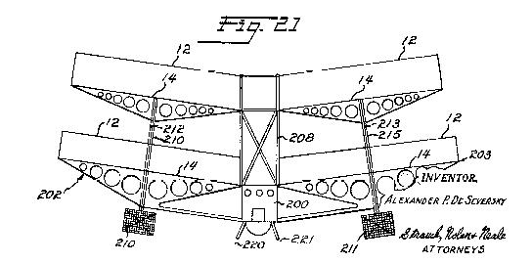  Stacked IONOCRAFT 1960s | 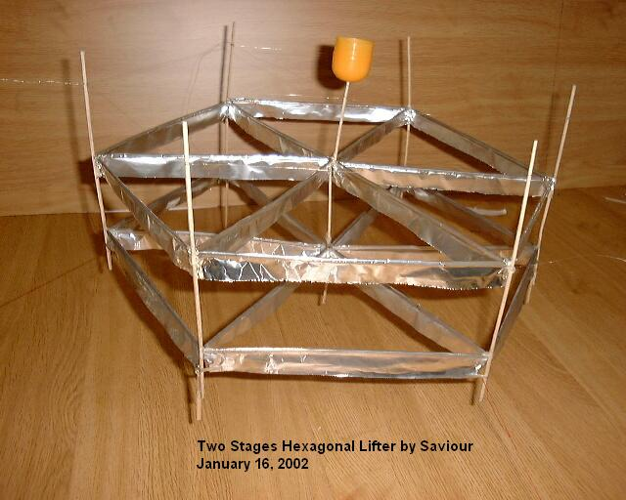  Savior Stacked LIFTER 2002

LIFTER PHYSICS
Whether or not Jeff Cameron knew it at the time he constructed his lifter
prototype, what he was actually building was a 3 dimensional representation of a drawing on a patent application by TT Brown in the 1950’s. In the patent
application, the drawing shows a positively charged wire suspended over a
grounded foil body which was meant to demonstrate the most basic Biefeld-
Brown effect generator. While Brown’s drawing is a little different than Jeff’s
design, the resemblance is uncanny enough to indicate that both of these men had the same basic force in mind.

** On the main lifter page

http://jnaudin.free.fr/html/lifters.htm

Jean-Louis states categorically…

” On June 2001, Transdimensional Technologies has presented the Lifter1 and Lifter2 devices. These devices are able to lift their own weight and they are a "modern version" of the Townsend Brown Electrokinetic Apparatus. The Lifters are using the Biefeld-Brown Effect to generate the main thrust to self levitate. A Basic Lifter cell is composed of three Townsend Brown asymmetrical capacitors joined so as to form a triangle “ Hardly “New” or “revolutionary” technology. **

IONOCRAFT “milti unit triangle” 1960s | “Lifter 1”

TT Brown’s patent indicates that this Biefeld-Brown effect generator works due to
a gradient electrostatic-field between the wire and the foil – in essence, these two
elements compose a low-efficiency, high-voltage air-gap capacitor in which the
difference in geometries between the two capacitive elements generates a net directional force from the larger element towards the smaller element. Jeff
Cameron seems to have a practical axiom that goes along with this scientific
philosophy, which is that there must be both a leakage current and a capacitance
between the wire and the foil in order for the lifter to function.
Conventional physics says that two capacitor elements of different sizes will not generate a net-directional force, so what gives? This is actually the thinking that convinced me to abandon my research into Biefeld-Brown effect technology in 1996 – physics says it doesn’t work.

** Obviously wrong since we have flying craft… **

What the books say will happen is that since the wire can only maintain a lower-capacitance than the foil, the overall capacitance between the two elements will be reduced to be equivalent to that on the smallest element (or plate) in the capacitor. This, of course, assumes a 2- element series-wired capacitor, such as the lifter.
I can give you the conventional physics answer to this small riddle by simply
saying that the lifter uses a manifestation of ion-wind. This would state that the
electrons crossing the air-gap cause a breeze that causes thrust – since the
breeze would be traveling down from the wire to the foil, the thrust would be up,
as demonstrated in testing. In the ion-wind explanation, the electrons are emitted
from small-diameter of the positively charged wire in such great abundance that
they move a significant airflow down to the foil where they are absorbed and
transported electrically back to the HV power-supply’s electrical ground.
Conventional physics would seem to have the theoretical answer to why the lifter
causes lift, but in the experimental setting, which is what we now have an
abundance of thanks to Jean-Louis Naudin, the conventional physics explanation
doesn’t suffice. Experimentally, there are several deviations from the ion-wind
explanation that seem to invalidate it. For instance, if you completely contain the lifter in a plastic-enclosure, it will still generate lift – this would not be the case if a breeze was responsible for lifting the device. How could it be, if the breeze is limited to the inside of an enclosure which itself is levitating?
A more compelling proof that Biefeld-Brown is something other than ion-wind comes from Purdue University, where the lifter experiment was replicated inside a vacuum-enclosure with positive results. While ion-propulsion can work in space, it usually assumes that there is argon, krypton, or other noble gas to be used as the propellant – the vacuum enclosure showed that with no gas available for transport the lifter showed a moderate improvement in performance.

The vacuum enclosure tests are definitely compelling evidence that something
else is going on other than ion-wind – at least compelling enough for NASA to file patent number 6,317,310 – “Apparatus and Method for Generating Thrust using a Two Dimensional, Asymmetrical Capacitor Module”. The NASA patent description – which can be accessed from Naudin’s lifter website – is as vague is it is compelling in that NASA is basically requesting a patent on any technology that generates force using two geometrically dissimilar capacitive plates. Disregarding the fact that this patent was issued nearly 50 years after TT Brown’s patent using nearly identical descriptions and pictures, and also disregarding the fact that NASA also doesn’t understand why the lifter generates thrust, it seems apparent the this phenomena is gaining credibility in engineering
circles while physicists seemingly continue to deny that anything is going on.

** Vacuum enclosure tests of the original T.T. Brown units were also performed a number of times over the years. This proved the B-B effect was NOT only based on “ion wind”. The IONOCRAFT flight test program also proved this. The measured amount of “ion wind” was NOT enough to have lifted the craft. Additional B-B effect HAD to be in use to have produced enough “lift” for the IONOCRAFT to have flown.
It should also be noted that the Popular Mechanics article on the IONOCRAFT mentions that it would operate at 62 MILES altitude (space) where the air is too thin to generate useable “ion wind”. NASA also “tested” the “Corona ion engine” for Sky Stations International in their vacuum chambers in the mid 1990s noting that it sustained thrust to extreme altitudes.

See… **

http://www.globalflow.com/archive/06091997/allstories.html

“ Wireless is ballooning
It's been the low-earth and medium-earth orbiting satellites capturing all the attention, with high-profile investor Bill Gates backing the ambitious Teledesic project, a number of projects moving off the drawing board and into production and the first clutch of Iridium satellites already in space. They are regarded as the glamour side of space communications.
In contrast, a project called Sky Station has attracted little press. Now, as its officials move from country to country, holding high-level discussions with government officials and signing up partners, Sky Station is starting to take shape, offering an intriguing new contribution to our rich wireless future.
Sky Station International plans to deliver high-speed, broadband services via telecommunications payloads on lighter-than-air geostationary platforms deployed in the stratosphere.
With an estimated life of ten years, the platforms would be held in their positions 21 kilometres above the earth with the help of propulsion engines. The designers believe it will be possible to return them to earth for refurbishment.
From their 21km altitude they would be able to provide telecommunications service to large urban areas, with each Sky Station providing a footprint 1,000km in diameter. They would be able to deliver high-speed wireless links direct to individual personal computers and to support local area, metropolitan area and wide area networks. Uplinks would be at 64Kbps to 2Mbps and downlinks from 10 to 11Mbps or so - allowing for very substantial downloads.
The stratosphere is high enough to give wide-area communications coverage akin to that of a satellite, but low enough to keep user equipment inexpensive - between $100 and $200.
The platforms, in effect helium airships, would be launched from existing airfields. The total cost of a Sky Station would be about $60 million which includes all ground station equipment.
The service would operate in the 47GHz band, with Sky Station officials now lobbying around the world to ensure that it will have consensus when the issue comes before the International Telecommunications Union's WARC conference in November.
However, the US government has already given the project its blessing, notifying the ITU in October last year that it intended to authorize 40 Sky Station stratospheric platforms over major US cities. Last month the Federal Communications Commission approved use of the technology in the 47GHz frequency band - the first such approval for stratospheric telecommunications.
At that time the president of Sky Station, Mr Alexander Haig, said the decision marked the beginning of a new age of high-speed Internet service directly to personal and portable multimedia devices.
Phase One of the project kicks off in 1999 and involves deploying platforms over New York, Los Angeles and Houston. Officials said this week that Italian cities would be next.
Sky Station's plans for the Indian subcontinent are also well advanced, with 12 cities targeted for platforms initially, including Delhi, Calcutta and Bangalore.
Bangalore has been tipped as the most likely location for Sky Station's Asian deployment facility and telecommand system. Earlier this year, the company signed a preliminary agreement to establish the facility with Mekaster Telematics and subsidiary Archana Technology Resource Parl Ltd. The platforms will be built by an international consortium, including Thomson CSF Communications of France, Finmeccanica SpA Alenia Aerospace of Italy, Scaled Composites Inc of the US, Lindstrand Balloons Ltd of the UK and Spar Aerospace of Canada.
Last week vice presidents Dr Y C Lee and Mr Chris Patusky were in Australia to talk to Federal Communications Minister Senator Richard Alston, departmental experts and officials of the Spectrum Management Agency, the body responsible for issuing spectrum licenses.
Mr Patusky said Sky Station hope to have a platform positioned over Sydney for the Olympics in 2000. This would help kick off the project before a huge international audience.
The officials said the plan was to have 250 platforms in place worldwide by 2005 or 2006. The Italian supplier will build this entire phase of payloads, with Thomson providing the switching and ground station components.
Two key factors now lie before the project team: making a final decision about a propulsion engine; and winning general support from the international wireless community for use of the 47GHz band for the Sky Station system.
Nasa has conducted tests of the Corona Ion engine at its Lewis Research Centre and is known to also be looking at other systems.
"The NASA tests are completed and we know that the Corona Ion can hold a platform steady in the stratosphere," Dr Lee said.
Sky Station International is owned by a US corporation, Earth & Science Technologies Inc, with its technology suppliers also holding equity in the company.
There are plans for a private placement during the northern summer, closing off in about August.
So why haven't we heard more about Sky Station? The company says it's been busy, seeking out partnerships, putting the technology plan in place and lobbying ahead of that crucial WARC meeting later this year in Geneva."It's a case of one step at a time," Patusky said. “
and…

http://www.wired.com/wired/archive/4.09/es.sky.html?pg=1&topic=
“ Vacuum cleaners in orbit
Sky Station wasn't hatched as a telecommunications network, though. It began as an environmental project in the mid-1980s, when UCLA physics professor Alfred Wong dreamt of developing a giant, floating vacuum cleaner that would suck up and zap the chlorine molecules that help destroy the ozone layer. Such a device would have to remain aloft for long periods and be able to navigate. So Wong created the corona ion engine. “
** In actuality my 1979 patent application and 1996 rebuttal of the Wong application caused its abandonment and is the reason SSI is now down at 65K to 70K feet operating altitude with props. It IS however interesting that TWO DOD ex chiefs of staff Haig of Sky Stations International (SSI) and Abrahamson of Stratcom, (who would have had clearance to see the 1977 Nellis AFB test data) both retired and started companies employing my Sub Orbital Solar collector and Communications Station (SOSCS) technologies and ionic engines for station keeping in the stratosphere.

In 1996 I also sent the NASA ERAST office a large data packet with a request for funding for a high altitude sensor platform. In correspondence FROM this NASA office several months later they mentioned that Sky Stations had had meetings with them to seek their help in sizing the power systems for their telecommunications platforms; showing ONGOING NASA involvement with SSI and its systems well before their 2001 application.

This all shows that NASA was well aware of “prior art” to their2001 patent application. NASA MFS 31419_1 - Apparatus & Method for Generating Thrust Using a Two Dimensional, Asymmetrical Capacitor; - see the photo of the apparatus tested in vacuum by Transdimensional Technologies NASA did not list this work nor the Sky Stations patent and NASA/ SSI engine testing contract in the prior art section of their application THIS alone would void ALL of the NASA patent applications.**

See…. **

http://homepage.ntlworld.com/ufophysics/electrokineticsbrown.htm

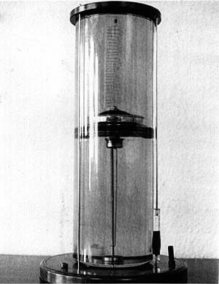 | http://www.soteria.com/brown/pictures/space4.jpg  T.T. Brown model B-B effect “space craft” being tested in a vacuum chamber from a government proposal.  http://www.soteria.com/brown/docs/egravity/space.pdf

THE EVOLUTION OF LIFTER TECHNOLOGY
Every good movie always has a sequel, and in technology, if at first a major
government agency ‘liberates’ your idea, it may seem that a sequel is in order. In the case of the lifter, it would appear that the NASA patent would cover this technology to at least some degree – at least until someone overturns this patent under the prior-art rule –

** This should be no problem…as mentioned above many years of “prior art” as well as documented proof of NASA’s prior knowledge of this system as the tester of commercial units employing B-B effect and used in exactly the way NASA intends to use it are available…. Public articles (Preventing patent application AFTER said publication) are well known and documented….. excepting NASA’s role as the government’s shill in the use of these patents to escape royalties. Both the T.T. Brown patents and the IONOCRAFT patents and a number of others have been shown to work not only by “ion wind” but by Biefeld-Brown effect. It is quite clear from their OWN statements that NASA has NO IDEA how the system works, making then NOT “one expert in the field.” However a number of theories and mathematical systems that FIT the observed experimental data HAS been put forward and presented in reviewed papers by a number of “Experts” in related fields.

With NASA ignoring ALL prior art, experiments, studies, patents, etc.
(some of the detailed studies NASA says don’t exist…)

See…
.
http://jnaudin.free.fr/html/selflifter.htm

http://sudy_zhenja.tripod.com/lifter_theory/main.html

http://jnaudin.free.fr/html/lftheory.htm

http://www.padrak.com/ine/RS_REF6.html

etc……
**

which means that the next generation has to be considerably more advanced to escape having the research and development be forfeit to the government.

** As we have now seen, “considerably more advanced” versions than NASA’s are already in the “public domain”. In addition even with the so called “modern improvements” the “HTA lifter” as shown in the IONOCRAFT, NASA, Transdimensional Technologies and others has yet to lift its own power supply and a payload.

IONOCRAFT article quote….
“The problem now is improving efficiency - getting enough lift from a given grid area and a given amount of energy, Present models cannot yet lift their own electric generators. they get power through a feeder cable, dangling down like an umbilical cord. Ionocraft engineers tend to be close-mouthed on performance figures.”

They are still working on it !!

Even the most “up to date” versions of “modern lifter” theories have not come up with an answer. Indeed the answer they HAVE come up with is not new… **
See…. **

http://jnaudin.free.fr/html/selflifter.htm

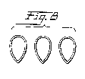  Inflated hollow collector grid units.  IONOCRAFT patent figure. | “ Just as a comment – it is a damn small value, as it is 29 times lighter than lifter 1 per unit length. But it might not be unreachable, a cylindrical collector (inflated tube evaporated with thin Al layer) would be used.  Saviour already tried such design and it shows promise. “  2002 “Self powered lifter report”
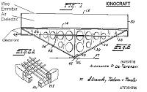  IONOCRAFT Grid collector 1960s | “ Considerable reduction of electrode stack specific weight compared to existing Lifters is required to achieve autonomous flight. Such improvement could be achieved by using mesh-configuration of both corona and collector electrodes, “  2002 “Self powered lifter report”

The pursuit of more advanced versions of the lifter technology is currently
underway by several independent inventors, as well as Transdimensional
Technologies themselves. Most of the private research by inventors has delved
into improving the current lifter design to produce a greater force output and
utilize less power to do so. Because the lifter is so simplistic in design, many of
these enhancements have been of a very basic nature.

Jean-Louis Naudin was the first independent inventor to do serious work with
improving the technology behind the lifter – and even so, the majority of his work
has utilized similar materials in more complex arrangements. Naudin has
demonstrated dramatically increased lifting forces by building a “lifter inside a
lifter” for demonstration purposes. Naudin has also done a great deal of work in
taking breaking up the concept of the single triangular lifter into a parallel series
of lifting cells –

** Not a simple triangle, the IONOCRAFT was a multi celled B-B effect craft having 4 “cells” (3 in the triangular form) making up a square with bisecting edges. Each of these squares was independently powered so as to “steer” the IONOCRAFT by use of a ground mounted “joystick controller” a feat not yet replicated by “modern lifter” experiments and included in the original patent application.

To Quote the 1964 Popular Mechanics IONOCRAFT article **
http://www.markwilson.com/ioncraft/ioncraft.html

“ IT WAS DOWNRIGHT SPOOKY. Without a sound, the peculiar, spiky contraption rose straight up, hovered awhile, climbed higher. Then it did a few graceful turns, stopped again, and just sat there silently in midair.
Steering with Voltage
Steering control is accomplished by applying different voltages to various parts of the craft. The part with the high voltage gets more lift, hence tilts up. The form of the Ionocraft doesn't matter. Any shape will fly, but de Severs ky assumes that round models in the form of a flying saucer will be the most easily maneuverable. By a simple joystick control, the pilot can lift any edge of the craft, producing pitch and roll as if the Ionocraft had elevators and ailerons. He can put the craft into any flight attitude-nose up or down, or banking to either side. Like the tilt of the helicopter rotor, this inclination pushes the craft forward, rearward, or sideways. “. Manned for:
CONTROLLED FLIGHT SYSTEM OF IONOCRAFT “LIFTER”
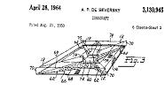  A 4 cell steerable IONOCRAFT “lifter” | IONOCRAFT showing wire emitter, air gap, grid collector. Ie. “A Lifter” | 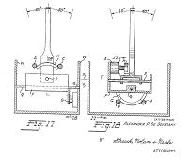  Joystick controller for IONOCRAFT.

The “modern” lifter page..(NOT yet accomplished.) **
http://jnaudin.free.fr/html/lftctrl.htm

Towards a controlled flight...
By Jean-Louis Naudin
created on October 10th, 2001 - JLN Labs - Last update October 21th, 2001
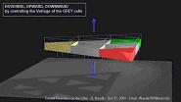  Vertical thrust control. | 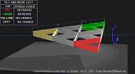  Roll control. | 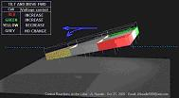  Pitch control

which means that these cells, working in parallel, can contributed to greater stability and higher force output than any single lifting element. Saviour – an independent inventor working with Jean-Louis Naudin – has done some of the most interesting improvements on lifter design since those by Naudin himself. Saviour’s concerns have not focused around the “bigger is
better” philosophy that many inventors have stuck by – he has done several
experiments to determine the radiation output, remote-controlled applications
development, and materials analysis and improvement on the lifter that others
have not had the time or expertise to conduct.
A recent experiment by Saviour demonstrates just how this gentleman’s foresight
is helping other experimenters – Saviour substituted nichrome heating wire for the common lightweight wire used for the emitter, and demonstrated that the lifting force greatly increased when a higher potential 12-volt charge was used to heat the emitter wire in conjunction with the standard high-voltage charge coming off it.

** While this may seem “new” to modern electronics experimenters, it is “old hat” to those from the “old school” of tube technologies. Indeed it was part of my rebuttal to the SSI / Wong “Corona ion engine” application that heating the emitter was neither “new” nor “unique” and was “obvious to anyone skilled in the field” for increased electron flow. From my 1996 rebuttal of the Wong / SSI “Corona ion engine” application…

“ Claim 7. The propulsion system as set forth in claim 1 further comprising means for
focusing light on the first electrode such that emissions of electrons from the
first electrode is increased.

Once again this claim is based in the previously voided claim 1. As mentioned above the heating of an electrode to increase the electron emission is a well understood and commonly used feature of electronics. Whether this is accomplished through the use of solar input through lenses or by inductive heating through RF energy, this type of enhancement would be obvious to anyone in the field and so does not represent any new or unique technology. This claim would be voided. “ **

One might also note that “a circular emitter and torroidal collector” as well as “other means to increase the number of electrons moved between the two” are also claimed as “recent modern improvements” and “possible future improvements”
However both of these were embodied in the construction and flight tests of the LTAS XEM-1 in the 1970s.

In his patent application of the mid 1990s SSI’s Dr Wong (the systen tested by NASA at that time) made the following claims…

----------------
- The propulsion system as set forth in claim 8 wherein the arrival rate increasing means is a horn shaped cylinder.
- The propulsion system as set forth in claim 8 wherein the arrival rate increasing means is a propeller.
- The propulsion system of claim 1 wherein the first electrode is a cylinder, the
second electrode is a toroid, and wherein the axis of the longitudinal of the
first electrode aligns with the longitudinal axis of the second electrode.

My 1996 PTO rebuttal to these claims was as follows…

“ Both of these claims 09 and 10 are various means of increasing velocity and density at the first electrode and thus through the system. The “Rate” increasing geometry of the ducts in Mr. Walden’s application also represent s a methodology for accomplishing this increase. Using a separate mechanical means to accomplish this would be an obvious methodology to anyone in the field and does not represent a new or unique feature or method.As stated earlier in this review a number of other propulsion systems presented in Mr. Walden’s application would serve to accomplish this. Mr. Walden’s subsequent improvements and addendum to his application (Beyond the scope of this response) in the electrode and system geometry and mounting methodology would make the inclusion of propellers and compressed air systems impractical and unnecessary.
Claims 09, 10 and 11 are deemed void.

Claim 12 is a word for word description of the electrode geometry displayed in Mr. Walden’s Patent application. This claim is obviously depicted and described in prior art and would void this claim even without the fact that it is based upon the previously voided base claim 1. This claim is void.”

-----------------

Indeed, even Savior’s most recent addition of a vector controlled lifter raised to flight using a set of “toy balloons” is but a crude version of the LTAS systems and patent pending technologies documented in the XEM-1 flight test program as demonstrated to the US Department of Defense (DOD) and Department of Energy (DOE) in the late 1970s Nellis AFB tests.

http://jnaudin.free.fr/html/savrclft.htm

Indeed, since I know of at least one other such craft that flew in the early 1990s on the television show “Marvelous machines – small world.” Savior’s “Balloon lifter” is not even the second craft to demonstrate a self powered ionic / EK aircraft but the third !! (Excluding DOD projects) **

“FIRST” LTAS XEM-1 R/C rigid hulled  LTA ionic airship flight test model 1970s | LTAS XEM-1 ionic / EK duct system 1970s
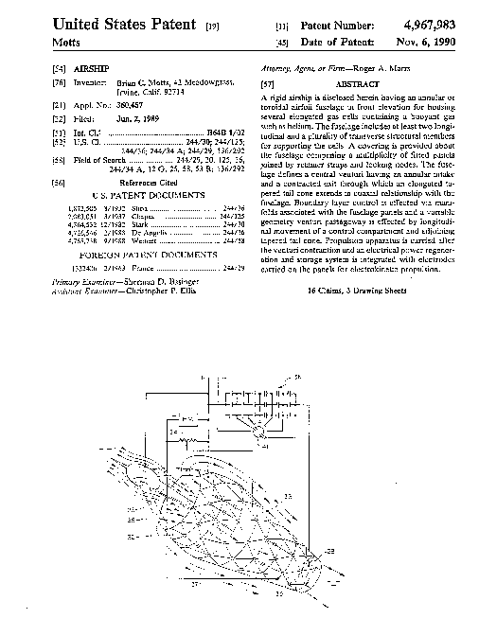  Motts ion airship patent 1989  “Second” | 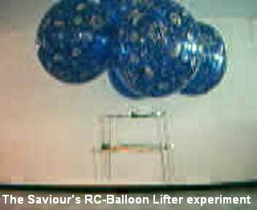  Savior “Balloon lifter” 2002  “Third”
Comments from Jean-Louis Naudin :
CONGRATULATIONS SAVIOUR !!!
YOU EXPERIMENT IS VERY IMPORTANT FOR THE LIFTERS PROJECT !!!
YOU HAVE DEFINITELY PROVED THAT :
  - A LIFTER WORKS WITH A POWER ON BOARD AND FULLY UNGROUNDED,
  - THIS IS NOT A SIMPLE REPULSION EFFECT BETWEEN THE DEVICE AND THE POWE SUPPLY,
  - IT IS NOW POSSIBLE TO BUILD A KIND OF SEMI-RIGID BLIMP WHICH WILL BE ABLE TO FLY SILENTLY WITHOUT PROPELLER AND A COMMON ENGINE...
This is a new step towards a full electric and propellantless propulsion...
GOOD WORK AGAIN, SAVIOUR.
Best Regards
Jean-Louis Naudin
Email: JNaudin509@aol.com
Main Web site : http://jlnlabs.org
Site France : http://jlnlabs.multimania.com
** Once again we see that commentary and credits given to “modern researchers” such as these above are incorrect as the accomplishments cited were made long ago by LTAS . **
Transdimensional Technologies – the developers of the initial lifter design –
** As we now know this is NOT the case…. **
are taking the approach to optimizing lifter performance to another level. They are currently not-so-secretly working on a 2nd generation lifter, which will consist of a 1-piece layered material to replace the current wire and foil design.

** This is also NOT new…. **

The layered material approach to the lifter is an idea that Jeff Cameron may or
may not have had after some lengthy discussions with Travis Taylor – the man
responsible for testing some anomalous materials known as “Art’s Parts”.
Art’s Parts were some pieces of material sent by an unknown person to the Art
Bell radio talk-show with a note stating that the they were pieces of UFO
wreckage taken from the often-cited “Roswell crash” in 1947. Whether or not the
pieces of material actually came from that crash is unknown, but Art Bell did the
honorable thing by sending them to an acquaintance in US Army research
named Travis Taylor for a professional scientific investigation.
Taylor, who apparently tested the materials after-hours in a world-class research
lab to avoid potential classification by his superiors, used an electron-microscope
to determine that the layered materials were actually pieces of metal – containing
several hundred microscopically thin layers of magnesium and bismuth. Taylor
also tested the layered-metal with a high-voltage apparatus, which seemed to
indicate that when a voltage was applied to the material, the layered metal would
move – and in some cases levitate.
Taylor reported his findings to Art Bell and sent video clips of his high-voltage
experiments, which eventually made it back to a permanent home on the Art Bell
radio show website. In addition, Taylor conveyed his belief that the only manner
in which the pieces of metal could properly be produced was through an
advanced form of electron-deposition technology, due (apparently) to an absence
of oxygen-molecules between the different layers of metals. Additionally, the
layers of metal were too thin to have been mechanically produced.
Jeff Cameron indicated that Transdimensional Technologies maintained some
contact at one point in time with Travis Taylor, apparently as professional
colleagues in the defense community in Huntsville, AL. I am not an expert on this
relationship, other than to say that to the best of my knowledge these two
individuals knew and contacted each other, and that this is how Jeff Cameron
might have come up with the 2nd generation lifter idea.

** No… one suspects that he has once again COPIED old TT Brown concepts…
See….

http://www.angelfire.com/scifi/EclipseLab/2k1/EG/cellgrav.html

“ Thomas Townsend Brown experimented with many different types of so-called gravitators during his work on electrogravitics. A gravitator is defined as at least two metal plates separated by a dielectric, with a high voltage applied there between. In this sense, the definition is almost that of a normal capacitor, but the empirical effects are much different. Brown's gravitators were either cellular or homogeneous. They were either many many small gravitators put into one box and wired in series, or simply a chunk of high dielectric constant material with electrodes at either end.

Brown used in one instance lead foil and cellulose acetate for a cellular capacitor, but made 10,000 layers in his Gravitator. The whole array weighed 10kg and when charged to 50 kilovolts experienced a force of 25,000 dynes in the direction of negative to positive. It was a similar model which he used to power a small model ship and amaze visitors by moving it with no apparent propulsive means. His homogenous gravitators tended to be slabs of either bakelite litharge (lead dioxide powder mixed with plastic and set) or the legendary Koolau basalt from Hawaii, used later in his experiments with petroelectricity. “

** Indeed, With modern “microelectronics production technologies” (ie. IBM’s “atom mover”) we can make “Art’s parts today. However, as noted above “cruder” versions of this “2nd stage lifter” system has been around for some time.

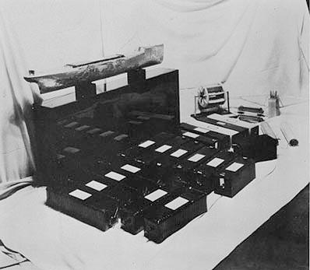  TT Brown “Gravitator powered boat” | 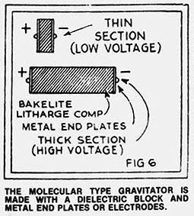 | 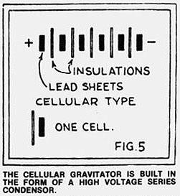 | 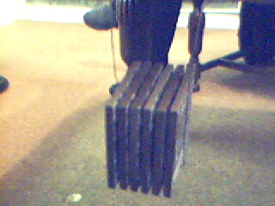  TT Brown “Layered Gravitator”

TT Brown “Gravitator” prior art to 2nd stage layered lifter units.

