LESSON # I

By Dr. Kiril Chukanov

Before starting work on this problem you must be willing to fight and overcome in yourself the scientific mentality which you received during your “righteous” university education. In other words, to be very “open-minded” to ideas which considerably differ from the currently accepted scientific dogmas.

Warning:
- Ball Lightning is not Plasma; Ball Lightning is a “Two-dimensional Macro Quantum Unit”;
- Quantum Free Energy is not a “bond energy” ( chemical or nuclear); Quantum Free Energy is a result of a Violation of Law of Energy Conservation in some particular quantum conditions;
Quantum Free Energy is not ZPE; ZPE is “science fiction” based on the ignorance and scientific ambitions of some free energy researchers;
- Plasma and nuclear scientists do not understand the nature of ball lightning and the nature of Quantum Free Energy; they cannot judge (from their scientific positions) the reality of this great scientific and technological discovery – do not take seriously their opinion and advices, avoid to discuses with them (this will be waste of time for you) this matter.

Figure I shows the scheme of QFE experimental set-up used by myself for some QFE experiments.

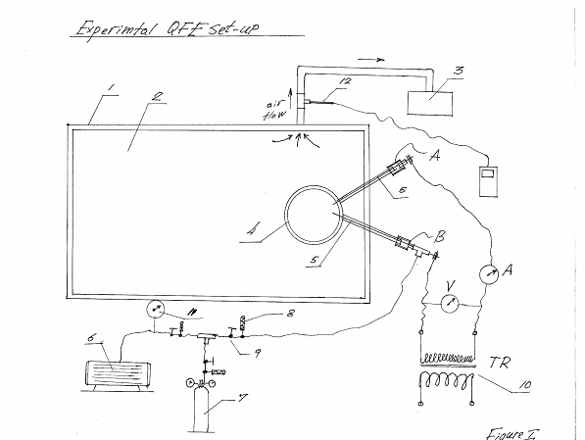

Legend:

1-industrial microwave oven “Amana”
Model CRC21T2
2450 MHz
208/230 volts
PWR in 3200 W
PWR out (microwave power) 2100 W

Note: you can use any other industrial microwave oven which assures at least 2000 W input microwave power.

2 – microwave cavity
3 – household vacuum pump (for cooling)
4 – quartz container (see Figure II)
5 – tungsten electrode (2 mm Dia)
6 – rotary vacuum pump; you can use any rotary pump which can create at least
p ≈ - (80-100 kPa);
7 – gas container (hydrogen, nitrogen, oxygen, helium, etc.)
8 – solenoid valve
9 – manual valve
10 – transformer

Transformer is needed to produce a “suitable” electrical current of “excitement”.

$$\begin{aligned}\left.U_{\text{pr}}≈{\text{220}}/{\text{240}} \text{Volts} | \right\}\left.U_{\text{sec}}≈\text{1000}−\text{2000} \text{Volts} | \right\}\end{aligned} \text{TR} I$$

For comparative experiments you need to also have a small power high voltage transformer (gas tube sign power supply, for example):

$$\begin{aligned}\left.\text{in}: \text{120} \text{VAC}; \text{60} \text{Hz}; 1\text{.}\text{45} A | \right\}\end{aligned} \text{TR} \text{II}$$

11 – vacuum meter
12 – digital thermometer - ΔT ≤ 0.01 C;

Experiment # 1 (according to Figure I)

Working gas – air
Quartz container as shown on Figure 2, and Photo1 & 2.

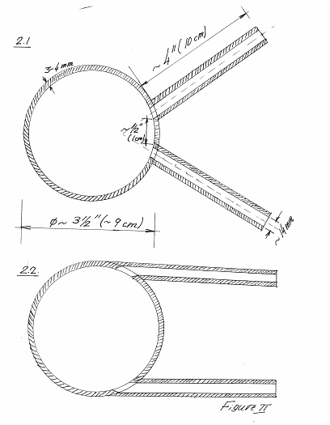

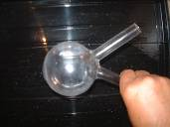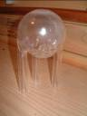
Photo 1 Photo 2

On Figure III are shown the terminals of the quartz containers.

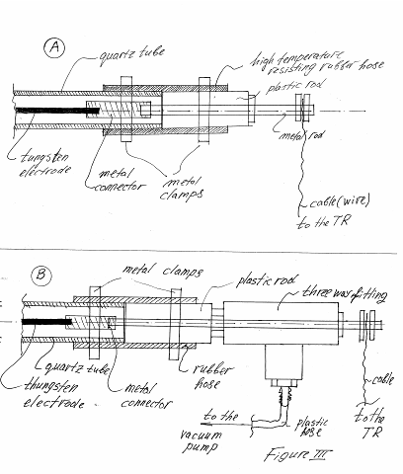

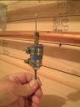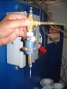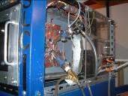
Photo 3 Photo 4 Photo 5

Steps of the experiments:
- Creating vacuum in the quartz container (as maximum as you can )
- Run the cooling system
- Run the microwave power

Glow discharge appears (regular plasma – pink color). See Photo 6 & 7. You can maintain this plasma state during several minutes until the temperature of the outgoing cooling gas (air) becomes constant – T₁.

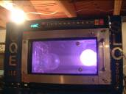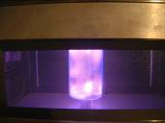
Photo 6 Photo 7

Prior to the experiment #1 plot “temperature-energy” must be built. See Figure IV.

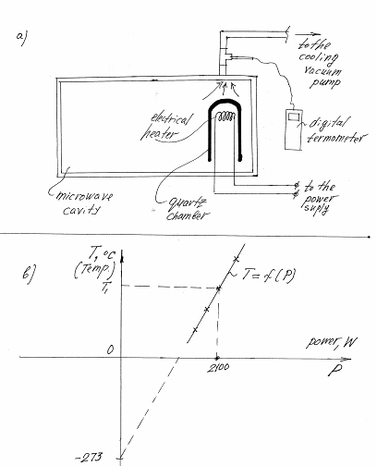
Fig. IV.

As a power supply you can use a 5 KW gas generator (you can vary the voltage in order to have different input power). Or another power supply.
For input microwave power P_{in} ~ 2100 W the plasma formation (low vacuum) shines like 15-20 W light bulb. The estimated total power of the emitted light photons is:

P_{light,1} ~ (2-3)% x (15-20) W ~ 0.3-0.6 W

- Almost the total amount of the input microwave energy is dissipated into heat. How big is the temperature of the plasma formation?

$$λ_{m}×T=\text{2898}×{\text{10}}^{−4}×K;$$

Where, - wavelength of the emitting photons, $\overset{˙}{A}$;
T – absolute temperature of the absolute “black body”;
K – Boltzman constant.

For red color plasma ($λ_{m}=\text{6300} \overset{˙}{A}$) we have: T ~ 4600, K;

Sun, for example, radiates mostly in the yellow spectrum:

$λ_{m}≈\text{5800} \overset{˙}{A}$, T ~ 5000, K;

The “Stephan- Boltzman” formula for energy radiation (absolute “black body”) is:

P_{rad} = σ x T⁴, W/m²

Where, σ - constant,
σ = 5.7 x 10⁻⁸, W/m² x K⁴;

Of course, our plasma is not an “absolute black body.” For relative comparison, however, the above formula is good enough.

- Next step is “slow increase of the gas-pressure in the quartz container”

You can see that for higher pressure (about “-30-40 kPa”) something very unusual happens – the glow discharge is transformed into a compact body – ball lightning. In your set-up you can increase the gas pressure up to 1 atm. You can see that higher the gas-pressure – the brighter the ball lightning (for the same input microwave power).
Make sure that tungsten electrodes touch only the ball lightning electron shell. See Figure V.

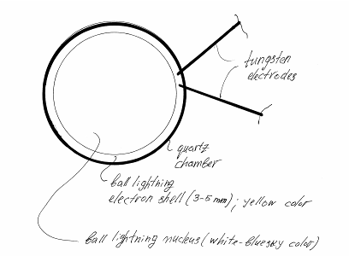
Fig. V.
On Photo 8 is shown tungsten rod.

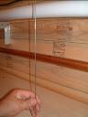
Photo 8

You can maintain ball lightning in this “unexcited” state as long as you want (hours, days …). Tungsten electrodes are not destroyed because “quantum” electrons are still not activated.
The ball lightning electron shell (yellow color) and the b.l. nucleus (white-blue sky color) are perfectly visible and distinguished from one another – you see a giant macro-atom.
The measured temperature of the cooling gas (air) is a little bit higher than the temperature of the cooling gas in the previous experiment (glow discharge plasma): T₂ ≥ T₁

The “over-unity” power is very little in this “unexcited” state.

The amount of “free” energy transferred from “quantum” electrons to the “standard” (“free” electrons, ions) substance depends strongly on the density of this substance: higher is this density – higher is the amount of “free” energy transfer – higher is the “over-unity.” If you can build a set-up where the gas-pressure can be raised much above 1 atm, then you can see that ball lightning “under pressure” is much brighter than the ball lightning under 1 atm. For gas pressure 20-30 atm you can observe a few hundred watts “over-unity” radiation for the same input power.
The estimated temperature of the b.l. nucleus (white – blue color) is:

$$T_{b\text{.}l\text{.} \text{nucleus}}≈8,\text{100} °K \begin{aligned}\left(T_{\text{white}}=\text{10},\text{000} °K | \right) \\ \end{aligned}$$

If considered as “absolute black body”, the b.l. nucleus must radiate:

P_{red} = σ x (10⁴)⁴

$\frac{P_{\text{rad},b\text{.}l\text{.}}}{P_{\text{rad},\text{plasma}}}=\frac{T_{b\text{.}l\text{.}}}{T_{\text{plasma}}}={\left(\frac{0\text{.}\text{81}×{\text{10}}^{4}}{0\text{.}\text{46}×{\text{10}}^{4}}\right)}^{4}≈8 \text{times}$!

On Figure VI is shown the graphic model of ball lightning.

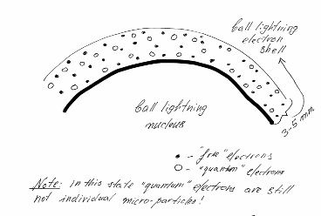
Fig. VI.

- Next step represents the “cream” of the experiment – excitement of ball lightning.

As we see from the above considerations, the amount of “over-unity” (free energy going with light photons) for “non-excited” ball lightning is small –
2-3 W.

On another hand, plasma body with temperature 8,100 K must produce 8 times more heat than plasma heated at 4,600 K. In fact, we don’t observe such dramatic increase of heat – the heat in both cases is almost the same. That means that the cause of increased radiation of photons is not the temperature of ball lightning. The real cause is the “quantum free energy”.

Here starts the great insight about the double nature of “quantum” electrons. Here is the edge between contemporary quantum physics and GQM. As mentioned in my last book (GQM, volume III), in the “non-excited” ball lightning (giant macro-atom) “quantum” electrons represent “quantum closed two-dimensional contours.” See Figure VII.

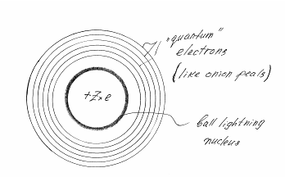
Fig. VII.

“Indefinite” quantum electrons can acquire an individual face if some external action is applied to the b.l. electron shell. An external electrical current can be this “excitement” factor.

Case one – “Zero-experiment” (see Figure VIII)

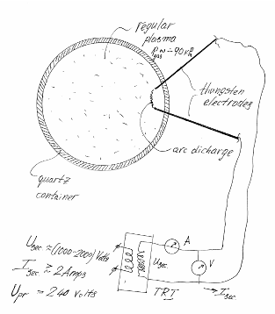Fig. VIII.

If you apply an electrical current to the regular plasma (low gas pressure) from transformer TRI, a simple arc discharge appears between both tungsten electrodes. Nothing special happens. The effect of this external electrical current is LOCAL – in the zone between both electrodes. The visible shining of this local arc discharge is very weak (2-3 W). Tungsten electrodes are not destroyed no matter how long the duration of this experiment lasts.

Case two – “non-excited” ball lightning (see Figure IX)

You increase the gas pressure up to 1 atm – regular plasma is transformed into ball lightning. If an electrical current is applied to the ball lightning from transformer TRII, a normal local discharge appears between both electrodes. Again nothing special happens. Very little power shining is coming from this local arc discharge. There is no destruction of the tungsten electrodes.
Obviously “quantum” electrons are still not involved as carriers of electrical current. Why? The answer of this question is mostly philosophical. In explaining the quantum phenomenon, Philosophy plays a more important role than Mathematics. This fact is ignored (or unknown) by contemporary physics.
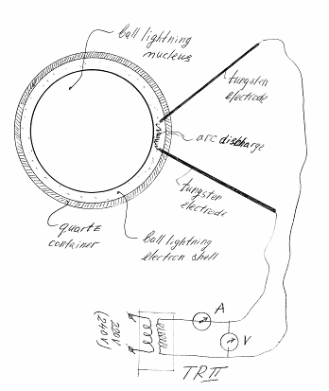
Fig. IX.

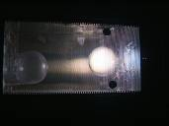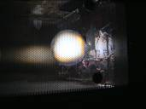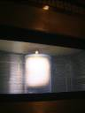
Photo 9 Photo 10 Photo 11

As well known, electrical charges are the carriers of the electrical current. In the zone of the b.l. electron shell there are some amount of “free” electrons (not connected with ball lightning) and some amount of “quantum” electrons (connected with ball lightning). If a small el. current is applied to the B.L. electron shell, then the whole electrical energy is carried only by the “free” electrons. Why? Because there exists in Nature a fundamental Principle of Economy. This principle limits the effect of the violation of the Law of Energy Conservation to a minimum. If the whole electrical energy can be carried by the “free” electrons (there is no “over-unity”), then Mother Nature involves in the game only the “free” electrons. We don’t observe any additional (extra) photon radiation. The effect of “free’ energy production (“over-unity”) is minimum – zero in this case. The effect is local.

Case three – “excited” ball lightning (TRI). (see Figure X)

If a stronger electrical current is applied to the B.L. electron shell (from TRI), then something very unusual happens – the whole surface of ball lightning starts to shine very intensely (like 10-12 KW light bulb). The intensity of light radiation can be estimated by the help of “photometer” (you compare the intensity of light coming from ball lightning with the intensity of light coming from halogen bulbs located at the same place).

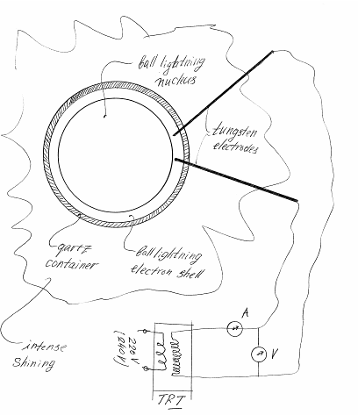
Fig. X.

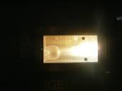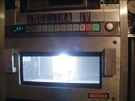
Photo 12 Photo 13

In this case (I > 2 Amps) some of the “quantum” electrons are involved as carriers of electrical current (“free” electrons are not enough in number to carry all of the electrical energy). The higher the applied el. current is – the more “quantum” electrons are involved – the bigger the “over-unity.” The measurement of ultraviolet radiation shows a dramatic increase of this radiation. Some soft X-rays start to appear.
After disconnecting the excitement, current ball lightning continues to radiate quantum free energy with almost the same power during 20-30 sec. See Photo 14.

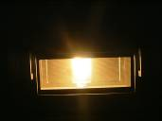
Photo 14

The effect of this external influence is NOT LOCAL any more –it affects the whole surface of ball lightning. Why? Because ball lightning is a “quantum macro-unit.” See Figure XI.

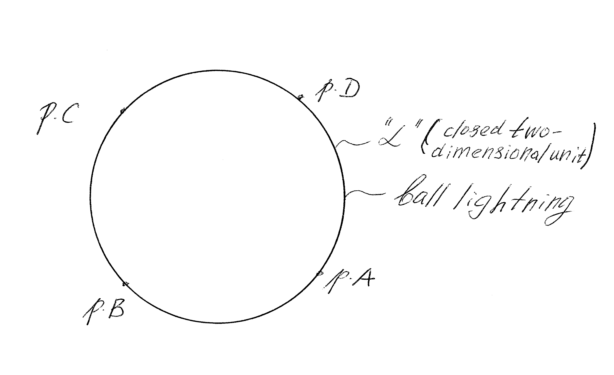
Fig. XI.

Note: the input “excitement” power is the same as in the case two!

If you touch ball lightning in some geometric point A, you in fact touch all geometric points on this quantum surface “ “. In applying an electrical current between two geometrical pointes (both tungsten electrodes) on this surface, you, in fact, are applying this current on the whole quantum surface.
Unlike “free” electrons, “quantum” electrons are extremely energetic. Within a short period of time (few seconds) “quantum” electrodes destroy the tungsten electrodes. You must turn off the microwave power and the “excitement” el. current because the internal surface of the quartz container is covered by a tiny layer of tungsten. This metal layer shields the penetration of the microwave field into the quartz container – shortly after the beginning of “excitement,” ball lightning disappears. The tungsten layer can be removed by the help of 2-4 % hydrofluoric acid in a bath for about 3-4 hours.
The estimated “over-unity” radiation is:

P_{rad} ~ (2-3)% x P_{visible light} ~ (2-3/100) x 12,000 W = (240-360) W

The power of ultraviolet “free “energy radiation is difficult (for me) to be estimated.
In parallel you can measure the temperature of cooling gas – T₃. This temperature is a little bit higher. The “over-unity” effect is mostly in the form of photon radiation.
And do not forget again – the input microwave power is the same. Both the input microwave energy and the energy of “excitement” current are totally dissipated into heat.
As you see, there is no need in long-time measurements; the effect of “over-unity” is so clear and so convincing.
How big is the input power of the “excitement” current? The current of “excitement goes through already created (by the microwave field) plasma (in the zone of b.l. electron shell). As it is well known, the formulas of electrodynamics are true only for solid and liquid states of matter.

$$I=\frac{U}{R}; P=R×I^{2}$$

Where, I – electrical current, Amps;
U – voltage, volts;
R – el. resistance, Ω;
P – power, W;

For plasma created by an external source of ionization (microwave field in this case) you cannot expect precise results in using the above formula.

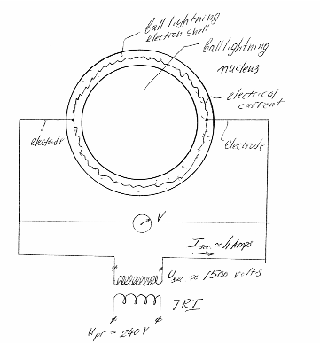
Fig. XII.

On Figure XII is shown the path of the applied current of “excitement” – around the b.l. nucleus. Electrical current cannot go through the b.l. nucleus!
Electrical resistance of the air-plasma located in the zone of the b.l. electron shell is very small.
R ≥ 0

The measured (in the described above experiment) value of I is:
I ~ 4 Amps

This current is big enough to involve some “quantum” electrons in the game – ball lightning starts to shine very intensively.

The difference of electrical potentials (measured by voltmeter) is very small – almost undetectable. See Figure XIII.

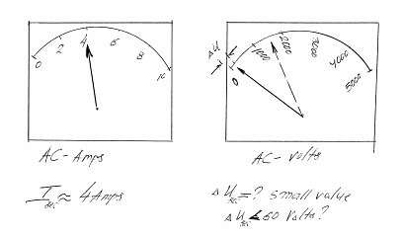
Fig. XIII.

$$R=\frac{ΔU}{I}=\frac{ΔU}{4}, Ω; \text{maybe}, R=\frac{\text{60}}{4}=\text{15} Ω ?$$

$$P_{\text{exc}}=R×I^{2}=R×4^{2}=\text{16}×R, W; P≈\text{15}×\text{16}=\text{240} W$$

Most likely this value is much smaller.
The whole power of “excitement” is dissipated as heat in the plasma.
The comparison of the temperatures of the “zero experiment” (only plasma) and the temperature in the experiment with “excited” ball lightning (the same input microwave power an the same power of excitement) shows that “excited” ball lightning produces slightly more output heat power (going with cooling gas).
The effect of “excitement” for both cases (regular plasma and ball lightning), however, is very, very different, for the same input powers!
Because of very small electrical resistance of plasma in the zone of b.l. electron shell, there exists a state of “shortage” in the secondary coil of the transformer TRI. This coil is heated up very quickly.
Obviously technology with direct excitement of ball lightning (electrodes touching the surface of ball lightning) is not good for practical use. Because of very fast destruction (by extremely energetic “quantum” electrons) of the tungsten electrodes and very quick excessive heating of the secondary coil of transformer TRI, we must stop the process a few seconds after its beginning.
In order to avoid this technological inconvenience, we can use a “non-contact” method of electrical “excitement” – with electromagnets.
Another method of “excitement” is to use an external dense flow of low energy electrons shouted into ball lightning from an electron gun. My opinion is that this method of excitement is the most perspective for practical use.

Be tuned for next lesson!

Salt Lake City, Utah
September 8, 2005

