Lifter Construction Guide
Information Unlimited | www.amazing1.com
Warning Notice: This document is intended for educational use only! The project described in this document uses extremely high-voltage power-sources, and is intended for readers over 21 years of age who are experienced working with dangerously high-voltages. If you are not a legal adult, or are not proficient working with dangerously high-voltages, do not try to build this project without expert supervision. The author of this document is not responsible for any death, injury, or property damage resulting from or relating to the procedures shown or devices described in this document.
Purpose of this Document: This document provides a step-by-step description of the methods and procedures involved with building a prototype electrokinetic propulsion-device. If properly constructed, this device will generate enough force to levitate itself from a resting surface.

Step 1: Obtain Required Materials
- 2mm by 6mm balsa-wood strips
- 30-gauge enameled copper magnet-wire
- Aluminum Foil
- 1 Tube “Super-Glue” or “Krazy-Glue” Brand cyanoacrylate adhesive
- Sewing Thread
- 1 hobby knife
- 1 25,000+ volt DC Power supply
- 1 Scotch-Brand tape roll
- NOTE: For more details, please see included ‘Required Materials’ document.

Step 2: Cut Balsa Support-Struts  → Cut the balsa-wood strips in half to create 2mm by 3mm strips. Cut these into two sets balsa struts – 1 set of 3 struts 20 centimeters in length, and a second set of 2 struts 11 centimeters in length.  Bevel the edges of each of the 20cm struts to allow it to be glued later at an angle to the 11cm struts. The beveling should be about 30 degrees in slope, and remember to bevel both ends on the same side of the balsa face. |  | 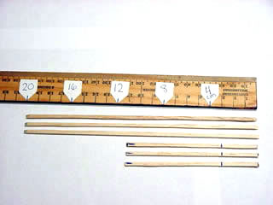
Step 3: Assemble Balsa Struts  → Mark each of the 11cm struts at the top (to help you remember which end is up) and again at a mark 4cm up from the bottom.  Sparingly use super-glue to attach each of the 3 vertical 11cm struts to a 20cm horizontal strut as shown in the picture.  In the picture, the beveled ends of the 20cm struts have been glued at right angles at the 4cm mark on the vertical struts. |  | 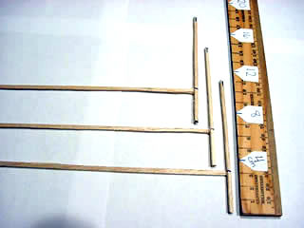
Step 4: Complete Chassis Assembly  → Similar to step 3, glue together the 3 pieces of the Lifter frame using super-glue. Glue the unconnected ends of the 20cm struts to the other side of the 4cm mark that you created on the vertical strut in Step 3.  Ensure that the ends of the Lifter line up as shown in the picture. |  | 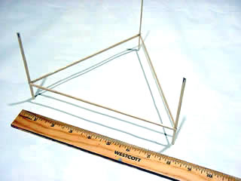
Step 5: Cut Aluminum Foil Strip  → Cut a strip of aluminum foil 5cm wide and approximately 1 meter in length. This foil strip will be used to surround the bottom-part of the Lifter. |  | 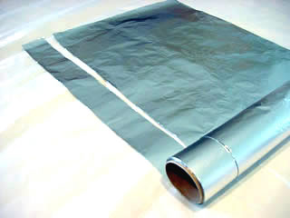
Step 6: Fold Foil Around Chassis  → Put glue on the 20cm strip and hold it onto the foil until it sets. Notice in the picture how the foil is even with the bottom of the vertical struts. If done correctly, you should have an extra 1-centimeter of foil above the 20cm balsa horizontal strut.  Roll the Lifter chassis down the length of the foil, gluing for each side of the chassis as you go.  You must have an extra 1cm lip above the horizontal struts to reduce ion-leakage. |  | 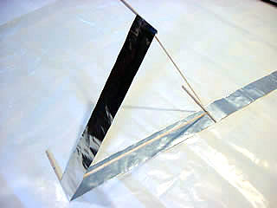
Step 7: Fold down Foil Edges  → Cut the corners around the top of the 1 cm lip above the horizontal struts and fold the foil over the top of the strut for each of the 3 Lifter sides.  Use a piece of Scotch-tape cut in half lengthwise to hold the folded corners as close to the inside of the foil as possible and reduce leakage. |  | 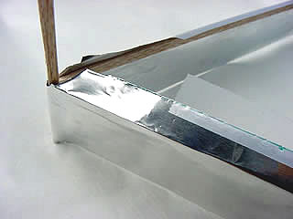
Step 8: Attach Ground Wire to Foil  → Poke a small hole through the foil skirt and run the ground-wire through it as shown in the picture. The hole should be behind the strut so that the wire is supported by it.  Make sure to strip the ground-wire of its enamel coating before you connect it. The ground wire must have a section of bare-copper to contact the foil in order to work.  Give yourself about 2 extra feet of wire off the lifter to connect it to your power-supply’s ground. |  | 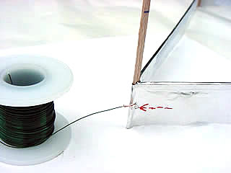
Step 9: Attach Corona Wire  → Approximately 4 cm up from the top of the foil, or about 2cm from the very top of the vertical support struts, run a length of magnet wire around all three vertical struts.  Make sure to loop the wire around each of the vertical struts at least once to ensure that it stays in place, and when you come back to the first vertical strut, tie the wire off so that the corona wire runs around the entire frame of the Lifter. After you have the corona-wire in place, scrape some of the enamel off of the wire. |  | 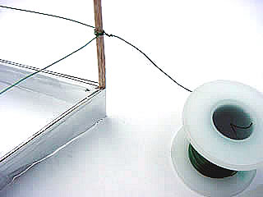
Step 10: Finished Lifter  → If you have correctly followed the above steps, you should have a Lifter prototype identical to the one shown here.  Use the “Testing Guide” document to assist you with testing the Lifter, and use the “Troubleshooting” document if you encounter problems while testing. |  | 