How to make a raw scan e-book using FineReader
An excellent tutorial, graciously submitted by Daddio.
I am assuming here that you have a computer, a scanner, and FineReader 5.0 OCR software. Naturally you can just follow along to see what is happening. My real purpose here is to let people know how easy this is to do so we can encourage more "new" material.
So, turn on your scanner, start up FineReader and follow the bouncing ball (God how that must date me!).
The following is a screenshot of how FineReader looks when you first start it up. I have the window shrunk down some for space and viewing considerations. In real life, you might want to expand the window to full screen size, especially when viewing the processed text.
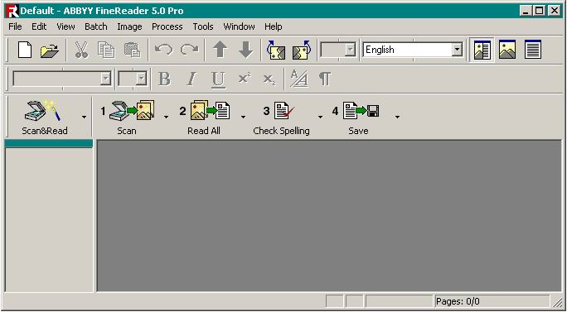

The whole purpose of this is to show how to scan in an entire book as quickly as possible. Speed will depend also on the particular scanner hardware you use. For the record, I use the Epson Perfection 1200U, and I can make a raw scan of a 400-page-paperback book and save it as text in under an hour. I'm about to show you how to set up FineReader to do it's part. The rest is up to you and your scanner.
From the Tools menu, select "Options...", and then select the "Scan/Open Image" tab. For our purposes here, it is absolutely critical that you select "Use FineReader interface," and you should check "Display options dialog before scanning."
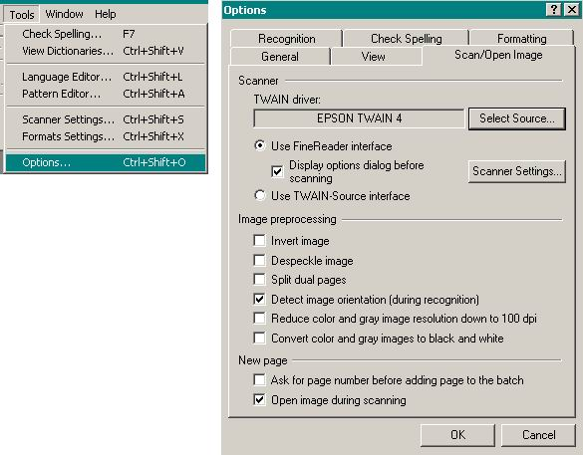

While we're here, click on the "Scanner Settings..." button and lets make sure a couple other things are set up properly.
You can also get at this window from the Tools menu and selecting "Scanner Settings..."
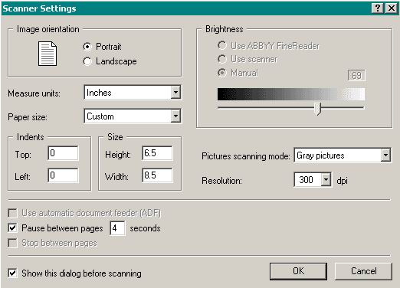
You can do books fastest when they fit on the bed of the scanner in portrait orientation with side-by-side pages both fitting comfortably on the glass. I already know that the "standard" sized paper-back book I will be using will work well at a height of 6.5 inches. Also note that to go along with this special height I have selected "Custom" for Paper size. I have had excellent luck with Gray pictures at 300 dpi (I haven't even bothered to try other settings). You can only adjust the brightness while in Black and White picture mode, but don't worry about the brightness setting unless you are getting a lot of OCR errors. Also note that I have checked "Pause between pages" and have decided on a delay of 4 seconds. You might want 5 or 6 seconds until you get used to racing through a book. Also, I like to see this dialog before the automated process starts in case I want to adjust something like page height or orientation so I have "Show this dialog before scanning" checked.
Whew! That's most of the setup.
One very common complaint about e-book text files is that there is a linefeed at the end of each line instead of only after paragraphs where they belong. Let's make sure that doesn't happen with our text file. From the Tools menu select "Format Settings..." and select the TXT tab.
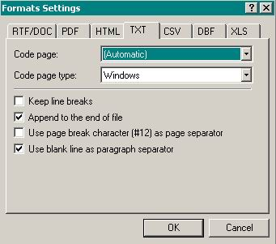
DO NOT check "Keep line breaks." DO check "Use blank line as paragraph separator." If you do these two the opposite way, you will have a linefeed after each line and no indication of where the next paragraph starts. There will be no way to correct this later on. With things marked as they are in this window, you will end up with squared off paragraphs with a double linefeed between them. Later, if you wish, you can alter the paragraph style with Textify or with a search and replace in your favorite word processor.
Just a couple more things, promise. From the Tools menu select "Options..." and then the Recognition tab. Copy my settings. Maybe the most important is the "Autodetect layout" which does a fine job of differentiating between two pages in the same scan. Sometimes it will read across the top of the page and put both page headers next to eachother. Besides that minor detail, I have never had any other problems with FineReader differentiating between the facing pages.
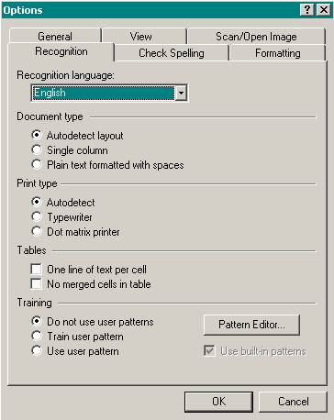

Lastly, before we start playing with the scanner, from the Process menu select "Start Background Recognition." You need to select this every new session as this setting is not retained like all the others we've discussed. With this selected, the text will be interpreted from previous pages while you continue to scan the next pages. This can save 20 or more minutes of waiting while it "reads" the entire book if you don't do this first. If you want to select specific zones or read some areas in a certain order, you will NOT want background recognition.
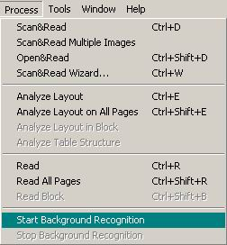

Finally, it's time to actually put a book on the scanner!!!
Grab an average-sized paperback book, one that will fit on the scanner open in portrait mode. Oops! The cover seems to have gotten all blurry. No matter. Please note that if you do not set the height setting for the scan then the scan head will travel all the way down the bed past the book and to the bottom. This will waste a LOT of extra time.
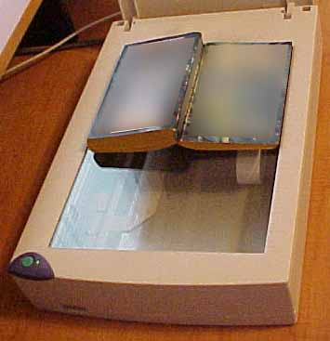
First we need to measure the height of your book. Remember, the scanner setting window will pop up every time to start scanning. First let's do as many single scans as necessary to get the travel of the scan head just right. To the right of the button labeled "1 Scan" is a tiny little down arrow. Left click and hold on that arrow and a pop-up menu appears. Select "Scan Image..." Note how the Scanner Settings window pops up. Click OK and put the book to the top of the scanner and push the spine down toward the bed and hold it there until the scan is finished. If you didn't get the Scanner Settings window to pop up first, access it from the Tools menu, select "Scanner Settings" and check "Show this dialog before scanning."
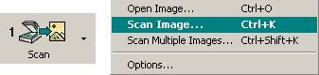
Keep adjusting the height setting until your book scan looks about like mine. Note: you can drag the center pane left or right until you can see the entire scan. Also you can use the magnifying glasses "-" and "+" to adjust the viewing size of the scan. Notice how mine has about room for another two lines of text. What I actually did was find the exact point that the light barely went past the bottom of the book (and thus hurt my eyes) and then backed it up a tenth of an inch. I'll wait until you get all this just right.
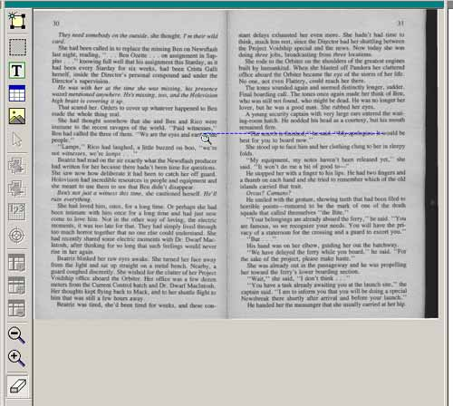

If you like, highlight the last page where you finally got everything right by clicking on the icon along the left of the screen. Use the very last one, scrolling down if you have to. Then click on the little down icon for the button "2 Read." And select the top item "Read." Now you should be watching the page be read. When it is done, the text will appear in a column on the right side of the screen. Adjust the center pane until you can see all the text. Ignore any highlighted characters and just look it over some for accuracy. I feel confident that everything came out just fine with maybe one or two errors at most. If you are new to this, I'm expecting you to be very impressed with what just happened.
Now let's wipe out all your hard work and start over. Click on any one of the page icons on the left and then "Select All" from the Edit menu. Hit the "Delete" key on your keyboard and click "OK" in the pop-up dialog window. Now we're ready to rock!
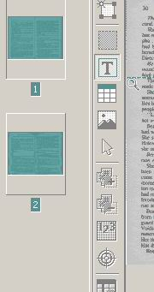
Let's make sure we're set up properly. Under the Process menu select "Start Background Recognition." Under the "1 Scan" button click the little down arrow and select "Scan Multiple Images..." We now have the "Scanner Settings" window open and when we click "OK" we will be in auto scan mode. "Pause between pages" should be checked and for this exercise have 6 seconds for the pause so you have plenty of time to turn pages.
Remember you want to have the book at the top of the scanner and to push the spine of the book toward the glass and hold it steady for each pass. Let's do about 10 passes and pretend that's the entire book. You can always continue where you left off when we're done. When you decide you're done with about ten pages, wait until the scanner starts the next pass and then click the stop scanning button (which is the same as the start scanning button "1 Scan").
Go for it!
Look over some of the pages if you like. Click on the page icons on the left and the main window will update with the picture of the text and the processed text. Now, just for kicks, quit FineReader and then start it right back up. Everything should still be there. That was just to show you how easily you can stop and pick up later where you left off (VERY carefully to start on the next page, look at your last page in FineReader before continuing).
So our entire book is completely scanned in and the text processed (really just a few pages but the process is identical). Time to save as a text file. Save wherever you want and name the file whatever you desire, but make sure your settings are the same as mine. Save As: Text Document. Save pages: All pages. File options: Create a single file for all pages. When you're ready save your file and then open it and compare with the original text. You might even run a spell check on it. So far as correcting errors goes, when comparing the book with your text file the page numbers sure come in handy.
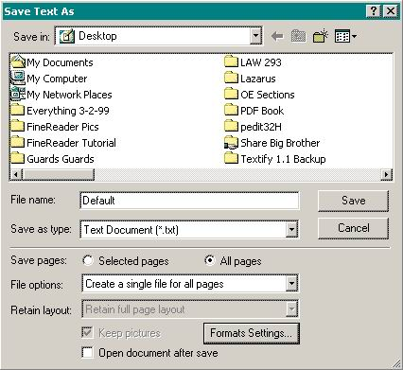
We'll be looking forward to your first "new" book post soon!

