Graphics Memory Reporting through WDDM
January 9, 2006
Abstract
This white paper provides information about the reporting of graphics memory through the Windows Vista™ Display Driver Model (WDDM) on systems running the Windows Vista operating system.
The current version of this paper is maintained on the Web at:
http://www.microsoft.com/whdc/device/display/graphicsmemory.mspx
References and resources discussed here are listed at the end of this paper.
Contents
Introduction 3
Graphics Memory Concepts 3
Dedicated versus Shared Graphics Memory 3
Discrete versus Integrated Graphics Adapters 3
BIOS Allocation versus Driver Allocation 5
Graphics Memory Reporting before WDDM 6
Graphics Memory Reporting through WDDM 6
Calculation of Graphics Memory 7
Example 1: 256-MB Dedicated On-board Graphics Memory on a Desktop 8
Example 2: 32-MB Dedicated On-Board Graphics Memory on a Mobile PC 10
Example 3: 256-MB Shared Graphics Memory on a Mobile PC 12
Retrieving Graphics Memory Values on WDDM 14
Resources 15

Disclaimer
This is a preliminary document and may be changed substantially prior to final commercial release of the software described herein.

The information contained in this document represents the current view of Microsoft Corporation on the issues discussed as of the date of publication. Because Microsoft must respond to changing market conditions, it should not be interpreted to be a commitment on the part of Microsoft, and Microsoft cannot guarantee the accuracy of any information presented after the date of publication.

This White Paper is for informational purposes only. MICROSOFT MAKES NO WARRANTIES, EXPRESS, IMPLIED OR STATUTORY, AS TO THE INFORMATION IN THIS DOCUMENT.

Complying with all applicable copyright laws is the responsibility of the user. Without limiting the rights under copyright, no part of this document may be reproduced, stored in or introduced into a retrieval system, or transmitted in any form or by any means (electronic, mechanical, photocopying, recording, or otherwise), or for any purpose, without the express written permission of Microsoft Corporation.

Microsoft may have patents, patent applications, trademarks, copyrights, or other intellectual property rights covering subject matter in this document. Except as expressly provided in any written license agreement from Microsoft, the furnishing of this document does not give you any license to these patents, trademarks, copyrights, or other intellectual property.

Unless otherwise noted, the example companies, organizations, products, domain names, e-mail addresses, logos, people, places and events depicted herein are fictitious, and no association with any real company, organization, product, domain name, email address, logo, person, place or event is intended or should be inferred.

© 2006 Microsoft Corporation. All rights reserved.

Microsoft, DirectX, Windows, and Windows Vista are either registered trademarks or trademarks of Microsoft Corporation in the United States and/or other countries.

The names of actual companies and products mentioned herein may be the trademarks of their respective owners.

Introduction
The new Windows Vista™ Display Driver Model (WDDM) brings fundamental changes to the management of graphics memory in a system. The Video Memory Manager component is now responsible for the virtualization of the graphics memory and for handling the distribution of available graphics memory to various applications such as the Desktop Window Manager and others that rely on graphics memory. Through new Microsoft DirectX® application programming interface (API), the Video Memory Manager also reports the graphics memory to end users and makes it available to other applications.
This white paper discusses the various types of graphics memory and the new reporting mechanism for Windows Vista end users.

Graphics Memory Concepts
This section discusses the basic concepts related to the various types of graphics memory and their use by different classes of graphics hardware. These concepts are not new or specific to Windows Vista, but are important to understand in relation to the reporting of graphics memory in Windows Vista.

Dedicated versus Shared Graphics Memory
Graphics memory is generally classified into two major types: dedicated and shared.
Dedicated graphics memory, as the name suggests, is memory that is available for exclusive use by the graphics subsystem. Non-graphics applications and other subsystems in the operating system cannot access this type of memory. An example of dedicated graphics memory is the memory that is physically present on the “discrete” graphics adapter. This has been commonly referred to as “on-board” or “local video memory”—that is, close to the graphics processing unit (GPU). Dedicated memory, however, isn’t limited to on-board memory. A portion of system memory can also be dedicated to the graphics subsystem. This portion of system memory is never available to other subsystems or applications and is exclusively owned by the graphics subsystem.
Shared system memory is a portion of the system memory that can be used by the graphics subsystem when needed. For discrete graphics adapters, this type of memory is often referred to as “non-local video memory”—that is, far from the GPU. The shared memory is available to other subsystems or non-graphics applications when it is not being used by the graphics subsystem. Thus, it is never guaranteed to be available for graphics because it could already be in use.

Discrete versus Integrated Graphics Adapters
The differences between a “discrete” graphics adapter and an “integrated” graphics adapter can be highlighted in the context of dedicated versus shared graphics memory.
Discrete graphics adapters are commonly connected to the system through either the Accelerated Graphics Port (AGP), PCI, or PCI Express bus. Most discrete adapters have some amount of dedicated graphics memory with a very wide and fast local memory bus to access it, offering much better performance than the system memory.
Discrete graphics adapters can also access and use system memory through the AGP or PCI Express bus—the non-local video memory discussed earlier. Because system memory is accessed across the system bus, accessing it is much slower than accessing local memory.
Discrete graphics adapters generally share a portion of system memory with the CPU. Typically, these adapters do not ask for dedicated use of system memory for graphics, thus leaving more resources available for the rest of the system.
Figure 1 illustrates the memory subsystem of a typical discrete graphics adapter.
Note: The bandwidth numbers shown in Figure 1 can vary from system to system and are given as an example to establish an order of magnitude rather than an exact number for a specific configuration.
Figure 1. Typical memory subsystem for a PCI-Express discrete adapter
Integrated graphics adapters have the GPU integrated within the chipset north bridge. They do not have high-speed memory connected exclusively to the GPU as is the case of discrete graphics adapters. An integrated graphics adapter typically uses system memory for graphics purposes. It always dedicates a portion of the system memory to the graphics subsystem to guarantee a minimum amount of memory resource available to the GPU at all times, similar to the discrete adapters. It also shares another portion of system memory with other non-graphics applications and subsystems.
Figure 2 illustrates the memory system for a typical integrated graphics adapter.
Figure 2. Typical memory subsystem for an integrated graphics adapter

BIOS Allocation versus Driver Allocation
An integrated graphics adapter can dedicate a portion of system memory to the graphics subsystem by using two distinct mechanisms. Although each method reserves a portion of the system memory, they differ in the manner in which the available memory is reported to the user.
BIOS allocation: An integrated graphics adapter can reserve a dedicated portion of the system memory during the System BIOS power-on self-test (POST) phase of a system startup. This method effectively hides a portion of the system memory from the operating system. Thus, the reserved memory is not reported by the operating system as part of available memory resources.
For example, if the BIOS reserves 256 MB of system memory from a computer system with 1 GB of installed system memory, the operating system can see and report only the remaining 768-MB memory to the user through various control panels or through Windows APIs.
Driver allocation: The second mechanism that an integrated graphics adapter can use to dedicate a portion of system memory for graphics exclusive use is for the graphics driver to allocate that memory in its initialization routine during boot. In this case, the operating system still reports this graphics memory as part of the system memory even though this memory won’t be shared by the graphics driver with any other component in the system.
Taking the same example as before, if the graphics driver allocates 256 MB of memory from a computer system with a 1 GB of installed system memory, the operating system will still report 1 GB of system memory to the user and applications. Although a different amount of memory is reported in these two cases, the end-user impact is still the same—that is, only 768 MB of memory is actually available to the rest of the system.

Graphics Memory Reporting before WDDM
Prior to Windows Vista, graphics memory was reported as a single number through the Control Panel Display application. This number had no technical merit from an operating system perspective. The IHV graphics driver was solely responsible for providing this number to the operating system, which simply reported it to the user through the Display application.
Some legacy APIs exposed two types of memory: local and non-local. However, these numbers were selected by the driver and were mostly inaccurate.
A number of modern discrete adapters are marketed as having an amount of memory N, with that N being composed of both on-board high-speed memory and system memory. For example, a discrete adapter might claim to have 256 MB of graphics memory; however, it only has 64 MB of high-speed on-board memory, with 192 MB taken from system memory. Examples here include ATI’s HyperMemory and NVIDIA’s TurboCache technology.

Graphics Memory Reporting through WDDM
With the introduction of Windows Vista, the operating system is putting a much heavier load on the GPU than ever before. Overall system performance is now closely associated with the graphics subsystem performance and is directly affected by the amount of available graphics memory. Microsoft is enhancing how graphics memory is reported, so that end users can better understand the factors that directly impact the system performance.
In WDDM, the operating system can accurately account for each of the graphics memory contributors and report available memory precisely through new APIs. The following are some of the clients that use this reporting:
- Windows System Assessment Tool (WinSAT) checks for the available graphics memory and takes the action to turn off or turn on the Premium Aero Glass experience based on the amount of available memory.
- Desktop Windows Manager (dwm.exe) depends on the exact state of the available graphics memory on WDDM systems.
- DirectX games and other graphics applications for Windows Vista must be able to get accurate values describing the state of the graphics memory in the system. An inaccurate graphics memory number could drastically change the game experience for the user, for example.

Thus, Windows Vista enables the critically important capability of reporting the correct amount of graphics memory to the end user.
The following examples show the Display application and WinSAT applet reports of available memory, comparing numbers reported for different adapter and memory configurations on Windows Vista versus Windows XP.

Calculation of Graphics Memory
This section provides a detailed explanation of how various memory numbers are calculated.
Total system memory
Total amount of system memory visible to the operating system. Memory allocated by the BIOS doesn’t appear in that amount. For example, a system with a 1-GB DIMM with a BIOS reserving 1 MB of memory will appear to have 1,023 MB of system memory.
Total system memory available for graphics use
Total amount of system memory that can be dedicated or shared to the GPU, calculated as:
TotalSystemMemoryAvailableForGraphics =
MAX((TotalSystemMemory - 512) / 2), 64MB)
Commit limit on aperture segment
The amount of system memory that the video memory manager will allow to be pinned down (that is, memory mapped through an aperture segment) for GPU usage at any given instant. The total amount of system memory allocated for the GPU might exceed the commit limit greatly; however, the video memory manager will ensure that only up to a commit limit amount is actually resident in an aperture segment at any one time.
By default, the commit limit on a particular aperture segment is the size of that segment. The driver can specify a different commit limit when it enumerates the segment by using the DXGK_SEGMENTDESCRIPTOR.CommitLimit field. A commit limit specified in such a way applies only to the particular segment being enumerated.
In addition to per segment commit limit, there is a global commit limit on all aperture segment. This global commit limit is also referred to as shared system memory. This value is computed by the video memory manager but can be reduced to a lower value by the driver using the DXGK_DRIVERCAPS. ApertureSegmentCommitLimit capability bits; however, this is not recommended.
The video memory manager will not allow the per segment nor the global commit limit to be violated. If a particular segment as a commit limit of 1 GB but the global commit limit is 256 MB, the video memory manager will not allow more than 256 MB of system memory to be mapped into that segment.
Dedicated video memory
Sum of the size of all memory segments that do not have the specified PopulatedFromSystemMemory flags.
Dedicated system memory
Sum of the size of all memory segments that have the specified PopulatedFromSystemMemory flags. The value cannot be greater than TotalSystemMemoryAvailableForGraphics.
Shared system memory
MaxSharedSystemMemory = TotalSystemMemoryAvailableForGraphics - DedicatedSystemMemory
SharedSystemMemory = MIN(MIN(SumOfCommitLimitOnAllApertureSegment, DXGK_DRIVERCAPS.ApertureSegmentCommitLimit), MaxSharedSystemMemory)
Total video memory
TotalVideoMemory = DedicatedVideoMemory + DedicatedSystemMemory + SharedSystemMemory

Example 1: 256-MB Dedicated On-board Graphics Memory on a Desktop
This example shows an ATI discrete graphics adapter that has 256 MB of dedicated on-board graphics memory. It also shares system memory for graphics purposes.
a. Display application – Windows Vista
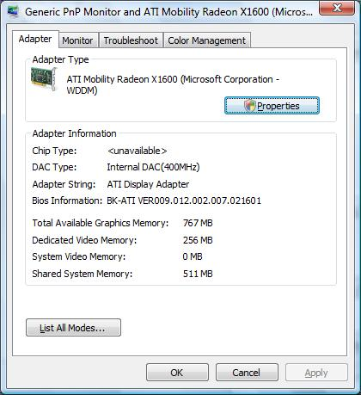

b. Performance Information and Tools application – Windows Vista
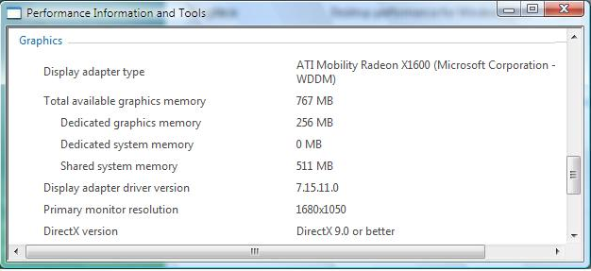

c. Display application – Windows XP
Note that the single “Memory Size” number reported in this case is just the dedicated graphics memory.
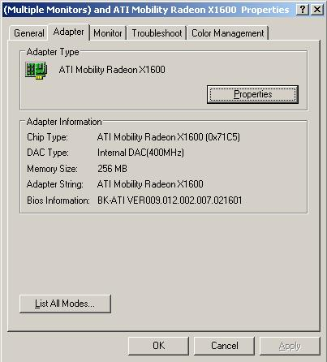

Example 2: 32-MB Dedicated On-Board Graphics Memory on a Mobile PC
This example shows an NVIDIA TurboCache technology discrete adapter present in a mobile PC. This adapter has some dedicated on-board graphics memory, but it mostly shares system memory for graphics.
a. Display application – Windows Vista
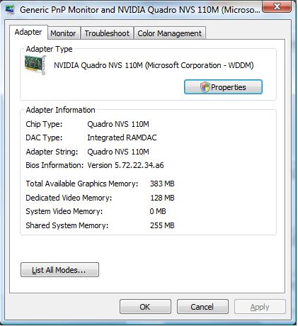
b. Performance Information and Tools application – Windows Vista
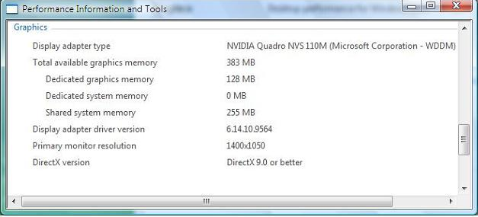

c. Display application – Windows XP
For TurboCache systems like the one shows here, the single “Memory Size” number reported is a combination, but not a total, of dedicated graphics memory and shared system memory.
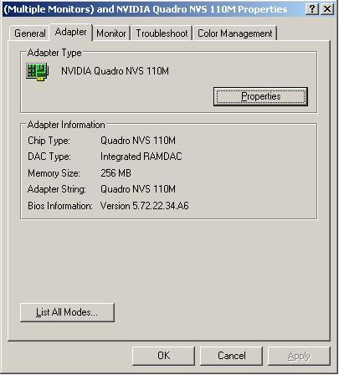

Example 3: 256-MB Shared Graphics Memory on a Mobile PC
This example shows an Intel UMA (Unified Memory Architecture) Mobile part that has no dedicated graphics memory on the motherboard; instead, it shares system memory for all graphics purposes.
a. Display application – Windows Vista
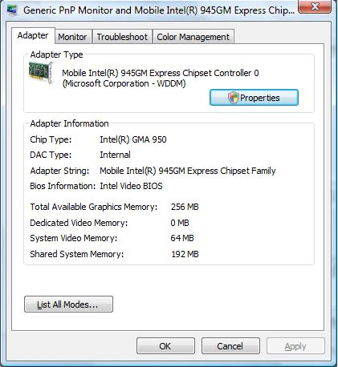

b. Performance Information and Tools application – Windows Vista
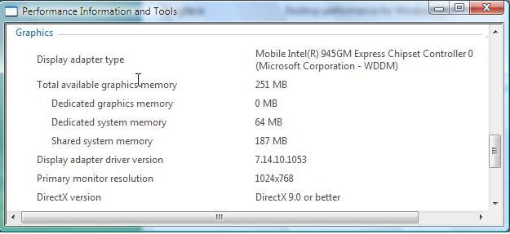

c. Display application – Windows XP
In UMA systems like the one shown in this example, the “Memory Size” number reported in Windows XP is a combination of the dedicated system memory and shared system memory.
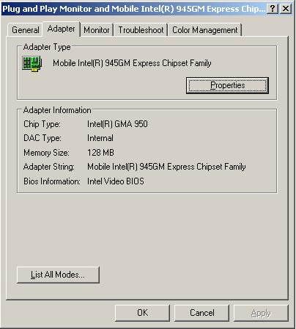

Retrieving Graphics Memory Values on WDDM
Software developers who create graphics applications can use the DirectX10 API in Windows Vista to retrieve the accurate set of graphics memory values on systems that have WDDM drivers. The following are the critical steps involved:
1. Graphics driver model determination:
Because the new reporting is available only on WDDM drivers, the application must first confirm the driver model by using the following API.
HasWDDMDriver()
{
LPDIRECT3DCREATE9EX pD3D9Create9Ex = NULL;
HMODULE hD3D9 = NULL;

hD3D9 = LoadLibrary( L"d3d9.dll" );

if ( NULL == hD3D9 ) {
return false;
}

//
/* Try to create IDirect3D9Ex interface (also known as a DX9L interface). This interface can only be created if the driver is a WDDM driver.
*/
//
pD3D9Create9Ex = (LPDIRECT3DCREATE9EX) GetProcAddress( hD3D9, "Direct3DCreate9Ex" );

return pD3D9Create9Ex != NULL;
}

2. Retrieval of graphics memory values:
After the driver model is determined to be WDDM, the application can use the new DirectX 10 API to get the values of the graphics memory. The data structure of interest is DXGI_ADAPTER_DESC, which is present in dxgi.h, included in the DirectX Software Development Kit (SDK). This works for all WDDM drivers and not just DirectX10 parts.
typedef struct DXGI_ADAPTER_DESC
{
WCHAR Description[ 128 ];
UINT VendorId;
UINT DeviceId;
UINT SubSysId;
UINT Revision;
SIZE_T DedicatedVideoMemory;
SIZE_T DedicatedSystemMemory;
SIZE_T SharedSystemMemory;
LUID AdapterLuid;
} DXGI_ADAPTER_DESC;

Because of the extensive use of graphics in the Windows Vista desktop and DirectX games, it’s important for software running on Windows Vista to be able to accurately determine the amount of available graphics memory. The Windows Vista Display Driver Model manages the virtualization of graphics memory in itself and also ensures accurate reporting of various aspects of graphics memory. Application developers and software vendors are encouraged to take advantage of the DirectX 10 API for retrieving the accurate set of graphics memory values on systems that have WDDM drivers.

Resources
Queries: If you have questions that are not addressed by this document, send e-mail to directx @ microsoft.com.
DirectX Developer Center on MSDN
http://msdn.microsoft.com/directx/default.aspx
Windows Logo Program Requirements Suite, Version 3.0
http://www.microsoft.com/whdc/winlogo/hwrequirements.mspx

